Laurey’s Favorite Recipes

BEVERAGES 6

HOT DRINKS 7

Hot Chocolate Mix 7

Hot Toddy 7

Milly’s Whiskey Sours 8

APPETIZERS 9

Beef Empanadas with Lime Sour Creame 10

Beer Cheese 11

Clams Casino 11

Crab Dip 12

Goat Cheese Appetizer 12

Mock Crab Dip/Artichoke dip 13

Mozorella Cups 13

Taco Dip 14

Warm Pastrami Dip 14

Aunt Rosanne’s Baked Brie 15

Aunt Rosanne’s French Bred Topping Appetizer 15

Millie’s Crab Bagel Appetizer 15

BREADS 17

Easy Devonshire Cream 18

Grandma Johnson's Scones 19

Grandmom’s Waffles 20

SOUPS 21

Broccoli Cheddar Cheese Soup 22

Chicken Tortilla Soup 25

Grandmom’s Escarole Soup(Italian wedding Soup) 26

Grandmom’s Pastine Soup 28

Italian Sausage Soup(Adapted) 28

New England Clam Chowder 31

Pumpkin Soup 32

Stuffed Pepper Soup 33

Thai Tom Kha Gai 34

Vegetarian Chili 35

SAUCES & DRESSINGS 36

Alfredo Sauce 37

Horseradish Cream Sauce 38

Spinach Salad Dressing 39

VEGETABLES 40

Asparagus 41

Minute Asparagus 41

Brocolli 42

Roasted Garlic Lemon Broccoli 42

Brocolli Salad 43

Dad’s Secret Brocolli Recipe 44

Brussel Sprouts 45

Tin Roof Brussel Sprouts 45

Cabbage 46

Sweet Restaurant Slaw 46

Carrots 47

Carrots and Apples Sauteed in Vodka 47

Green Beans 48

Green Bean Supreme 48

Peas 49

Peas with Shallots and Pancetta 49

Potatos 50

Roasted Sweet Potatoes with Maple Syrup, Orange and Spices 50

Zuccini 51

Grandmom’s Zucchini Fritters 51

Zucchini Medley 51

EGG DISHES 52

Grandmom’s Sausage Egg Quiche 53

Sausage Egg Casserole 54

Grandmom’s Zuccini Casserole 55

PASTA 56

Pasta Della Momma 57

Pasta In Pepper Sauce 58

Stuffed Shells 59

BEEF 60

Flemish Pot Roast 61

PORK 62

Pork Chops with Fresh Tomato, Onion, Garlic, and Feta 63

Pork Goulash 64

Marinated Grilled Pork 65

CHICKEN 67

Chicken Enchiladas 68

Green Thai Curry 69

Margarita Chicken Breasts 70

FISH 71

Grilled Fish Tacos with Chipotle-Lime Dressing 72

SEAFOOD 75

SCALLOPS 76

Grilled Scallops 77

SIDES 78

Brocolli Salad 79

Cole Slaw 79

Cranberry Oatmeal Delight 79

Donna’s Macaroni Salad 80

Pototo Salad 81

Grandmom’s Sausage Stuffing 82

Marinades 83

North African Marinade 84

North Indian Marinade 85

DESSERTS 86

DESSERT SAUCES 86

Joan’s Hot Fudge Sauce 86

CAKES 88

Baby Brownies 88

BAKLAVA 89

Chocolate Chip Cake 90

Bittersweet Molten Chocolate Cakes with Coffee Ice Cream 91

COOKIES 92

Melt Away Cookies 92

Three Nut Fingers 93

PIES 94

Apple Crumb Pie 95

Crème Brulee Pie 96

OTHERS 97

Chocolate Mousse Heatter 97

Mocha Cream 98

GRANDMOM’S RECIPES 99

Italian Sausage Filling 100

Escarole Soup(Italian wedding Soup) 101

Pastine Soup 102

Sausage Egg Quiche 103

Zuccini Casserole 104

Waffles 105

Zucchini Fritters 106

Untried But Interesting 107

Corn Casserole 107

Grilled Corn with mango-habanero butter 108

Recipe: Fall Corn Pudding with White Cheddar and Thyme 109

Tilapia Pitas 110

# BEVERAGES

C:\Users\Laurey\AppData\Local\Microsoft\Windows\Temporary Internet Files\Content.IE5\2RH9L8EI\MC900030217[1].wmf

C:\Users\Laurey\AppData\Local\Microsoft\Windows\Temporary Internet Files\Content.IE5\2NTOEIH9\MC900295765[1].wmf

C:\Users\Laurey\AppData\Local\Microsoft\Windows\Temporary Internet Files\Content.IE5\2RH9L8EI\MC900389564[2].wmf

## HOT DRINKS

### Hot Chocolate Mix

1 ½ cups of nestles quick(any instant chocolate drink mix without dehydrogenated oil)

1 packet of dried non-fat instant milk(1 quart packet)

* Mix nestles quick the instant milk thoroughly
* When ready to use, add 3 heaping tablespoons into a cup. Fill with hot water and stir
* Top with whipped cream, ice cream, or marshmellows to make it into a real treat.

### Hot Toddy

Prep Time: 5 minutes

Total Time: 5 minutes

Yield: 1 Cocktail

Ingredients:

* 1 oz brandy, whiskey or rum
* 1 Tbsp honey
* 1/4 lemon
* 1 cup hot water
* 1 tea bag

Preparation:

1. Coat the bottom of a mug or an [Irish coffee glass](http://cocktails.about.com/od/embellishments/ss/glss_gde_6.htm) with honey.
2. Add the liquor and the juice of the lemon quarter.
3. On the side, heat water in a tea kettle and add the tea bag to make hot tea.
4. Pour the steaming tea into the glass and stir.

### Milly’s Whiskey Sours

One can frozen lemonade

½ can water

½ can orange juice(diluted)

1-1/4 cans whiskey or southern comfort

Mix well . Can serve frozen or unfrozen.

# APPETIZERS

C:\Users\Laurey\AppData\Local\Microsoft\Windows\Temporary Internet Files\Content.IE5\N7HF1BQN\MC900214962[1].wmf

## Beef Empanadas with Lime Sour Creame

Hands-on time:35 minutes

Total time: 1 hour

Makes 24

1 Tbls olive oil

1 small onion, chopped

½ pound ground beef

1/3 cup golden raisins

2 Tbls ketchup

¼ tsp ground cinnamon

½ Kosher salt

¼ black pepper

2 store-bought refrigerated rolled pie crusts

1 large egg, beaten

½ cup sour cream

¼ tsp lime zest

* Heat oven to 374 degrees.
* Heat oil in a large skillet over medium heat.
* Add onions and cook, stirring occasionally, until soft(about 5-6 minutes).
* Add the beef and cook, breaking it up with a spoon, until no longer pink(3 -4 minutes).
* Stir in the raisins, ketchup, cinnamon, ½ tsp salt, and ¼ tsp of pepper.
* Using a 2 ½ inch round cookie cutter, cut out circles from the piecrusts.
* Divide the beef mixture amount the circles.
* Brush the edges with water and fold in half, pressing with a fork around the edges to seal.
* Transfer to a baking sheet and brush with the egg.
* Bake until golden, 20-25 minutes.
* Put the sour cream in a small bowl and sprinkle with the lime zest and serve with the empanadas.

Make ahead: Can be assembled and frozen up to 1 month in advance. If frozen, bake at 375 for 30 to 45 minutes.

## Beer Cheese

8 oz. wispride cheddar cheese(regular not soft)

8 oz. cream cheese

½ cup beer

Round loaf of pumpernickel bread

* Let Wispride and cream cheese come to room temperature.
* Combine with electric mixer.
* Slowly pour in beer and continue mixing.
* Chill.
* Serve in round loaf of pumpernickel bread surrounded by cubes of bread.

## Clams Casino

2 sticks margarine

4 cans minced clams

2 Tbls lemon juice

2 tsp parsely

1 tsp tobacco sauce

Parmesan cheese

Paprika

1 green pepper

1 medium onion

2 tsp of oregano

2 minced garlic cloves

1 cup of Italian bread crumbs

Slices of American cheese

* Melt margarine
* Save juice from 2 cans of clams and discard the rest.
* Put clams in melted butter and simmer.
* Add lemon juice.
* Meanwhile chop green pepper and onions, then add to clams and continue to simmer.
* Add oregano, parsley, garlic cloves, and tobacco sauce.
* Simmer for 5-10 minutes longer.
* Mix in clam juice.
* In small casserole dish add clam mixture and mix in 2 cup of Italian bread crumbs.
* Sprinkle with parmesan cheese and mix.
* Top with American cheese and paprika.
* Bake at 400 degrees for 10-15 minutes or until hot and bubbly.

## Crab Dip

1 lb. cream cheese

1 lb. lump crab meat

3 scallions, finely chopped

Touch of Worcester sauce and Dijon mustard

1 Tbls Chopped fresh parsely

Mix all ingredients and put into a serving dish.

Bake at 350 degrees for 45 minutes.

Top with fresh parsely.

Serve with sliced French bread or party ryes.

## Goat Cheese Appetizer

New York Times

Quick and easy.

* Slice soft goat cheese and brush with olive oil.
* Sprinkle with salt, pepper and chopped herbs, then with bread crumbs.
* Bake at 350 degrees until soft, about 10 minutes, and serve hot.

Serve with bread or crackers.

## Mock Crab Dip/Artichoke dip

From: Robin Schoonmaker

1 can artichoke hearts, well drained.

1 cup mayo

1 cup grated parmesan cheese

Mix all ingredients together well.

Season to taste.

Spoon into casserole dish.

Bake 30 minutes at 350 uncovered.

Serve with Triscuits or Bagel chips.

## Mozorella Cups

Prep Time:10 min

Total Time: 20 min

Portions: 15 appetizers

1 pkg(15 ct) Athens Fiko Shells

3 Tbls basil pesto

2 ½ oz(8 balls) of ciliegini mozarella, halved

2 oz roasted tomatoes, thinly sliced or sun dried tomatoes

* Place filo shells on baking sheet.
* Place ½ tsp pesto in each filo shell. Top with slices of roasted tomato and a cheese piece.
* Bake about 10 minutes or until cheese melts.

Make ahead- Can prepare and freeze or store in refrigerator until ready to bake.

## Taco Dip

Quick and Easy

**2 -8 ounce packages of cream cheese,**

**1 bottle of hot picante salsa**

**cheese**

**shredded lettuce**

**1 tomato, diced**

jalapeno slices

Mix cream cheese and salsa in mixing bowl.

Put in pie plate or quiche dish.

Top with layer of cheese, lettuce, tomato, and jalapeno slices.

Serve with tortilla chips.

## Warm Pastrami Dip

1-14 oz can artichoke hearts

1-6 oz package pastrami

1-8 oz carton sour cream

1 cup mayonnaise

1 Tbls horse radish

1 Tbls fresh or 1 tsp dried dill

¼ cup parmesan cheese

Rye bagel chips

* Combine artichoke hearts, pastrami, sourcream, mayo, horseradish, dill, and parmesan cheese.
* Spread in a 9 inch quiche dish or pie plate.
* Bake in 350 degreee oven for 20 minures. Serve warm with Rye chips.

## Aunt Rosanne’s Baked Brie

From:Rosanne Clark

Brie Cheese

Pesto

Sun Dried Tomatoes

Frozen puff pastry

* Rough chop sun dried tomatoes.
* Mix sundried tomatoes and pesto into the brie.
* Shape into a ball, flatten, and cover with puff pastry.
* Can cut puff pastry into shapes to decorate the top.

## Aunt Rosanne’s French Bred Topping Appetizer

From: Rosanne Clark

1 cup mayo

1 cup parmesian cheese

½ cup finely chopped onion

1 loaf of French bread

* Slice bread into thin slices.
* Mix mayonnaise, parmesian cheese, and onions.
* Spread on slices of French bread.
* Broil until light brown and crusty.

## Millie’s Crab Bagel Appetizer

From: Millie Clark

1 stick butter

1 can white crab meat

1 jar Old English Cheese(by velveeta made by craft)

1 bag of mini plain bagels

Garlic powder

* Mix together butter, crab meat, cheese, and garlic powder to taste.
* Cut mini bagels in half.
* Spread crab mixture on half a bagel.
* Broil until lightly browned.

# BREADS



|  |  |
| --- | --- |
| Easy Devonshire Cream |  |

|  |  |  |  |  |  |
| --- | --- | --- | --- | --- | --- |
| recipe image | |  |  | | --- | --- | | **Rated:** | rating |   **Submitted By:** STARP  **Photo By:** SANDIE47   |  |  | | --- | --- | | **Prep Time:** 15 Minutes | **Ready In:** 15 Minutes  **Servings:** 16 | |

"Cream cheese is beaten with cream and a touch of sugar in this clotted cream look-alike."

**Ingredients:**

|  |  |
| --- | --- |
| 1 (3 ounce) package cream cheese  -one recipe said 4 oz marscapone  with 1 tsp vanilla  1 tablespoon white sugar | 1 pinch salt  1 cup heavy cream |

**Directions:**

|  |  |
| --- | --- |
| **1.** | In a medium bowl, cream together cream cheese, sugar and salt. Beat in cream until stiff peaks form. Chill until serving. |

|  |  |
| --- | --- |
| ALL RIGHTS RESERVED © 2011 Allrecipes.com | Printed from Allrecipes.com 12/24/2011 |

|  |  |
| --- | --- |
| Grandma Johnson's Scones |  |

|  |  |  |  |  |  |
| --- | --- | --- | --- | --- | --- |
| recipe image | |  |  | | --- | --- | | **Rated:** | rating |   **Submitted By:** Rob  **Photo By:** S. Becker   |  |  | | --- | --- | | **Prep Time:** 15 Minutes  **Cook Time:** 15 Minutes | **Ready In:** 30 Minutes  **Servings:** 12 | |

"Tried and tested through 3 generations of kids. Simply the best anywhere!"

**Ingredients:**

|  |  |
| --- | --- |
| 1 cup sour cream  1 teaspoon baking soda  4 cups all-purpose flour  1 cup white sugar  2 teaspoons baking powder  Variations:  -Measurements for ½ batch of scones   * Add ½ cup ground pecans or ground walnuts and 2 tsp Cinnamon * Add White Chocolate Chips and dried Cherries * Add ½ cup dark chocolate chips and ½ cup of dried cherries(chop rough after measuring). * Add chocolate chips * Add raisins | 1/4 teaspoon cream of tartar  1 teaspoon salt  1 cup butter  1 egg |

**Directions:**

|  |  |
| --- | --- |
| **1.** | In a small bowl, blend the sour cream and baking soda, and set aside. |
| **2.** | Preheat oven to 350 degrees F (175 degrees C). Lightly grease a large baking sheet. |
| **3.** | In a large bowl, mix the flour, sugar, baking powder, cream of tartar, and salt. Cut in the butter. Stir the sour cream mixture and egg into the flour mixture until just moistened. Add variantions at this point |
| **4.** | Turn dough out onto a lightly floured surface, and knead briefly. Roll or pat dough into a 3/4 inch thick square. Brush with egg wash. Sprinkle with sugar. For small scones, cut into 1/3s and thirds in the opposite direction and then cut each piece in half into a triangle. Place them 2 inches apart on the prepared baking sheet. |
| **5.** | Bake 12 to 15 minutes in the preheated oven, until golden brown on the bottom.  -Serve with Easy Devonshire Cream(Ctl, Click). |

## Grandmom’s Waffles

3 eggs separated

1 ½ cup flour

2 tsp baking powder

½ tsp baking soda

1 Tbls sugar

2/3 cup sour cream

¾ cup milk

¼ cup oil

¼ cup melted butter

* Beat egg whites until stiff.
* Combine dry ingredients.
* Beat sour cream, milk, and egg yolks.
* Combine butter, oil, and liquid ingredients alternating with fats and dry ingredients.
* Stir until smooth.

Fold in egg whites.

# SOUPS

C:\Users\Laurey\AppData\Local\Microsoft\Windows\Temporary Internet Files\Content.IE5\CM2SOLAZ\MC900250807[1].wmf

## Broccoli Cheddar Cheese Soup

* 3 tablespoons butter
* 1 cup yellow onions or sliced leeks (white parts only, well rinsed)
* 1 celery stalk chopped
* 1 carrot stick chopped
* 1/4 teaspoon freshly ground [white pepper](http://www.foodterms.com/encyclopedia/white-pepper/index.html)
* Pinch nutmeg
* 1/2 teaspoon minced garlic
* ¼ tsp thyme leaves
* 3 tablespoons [all-purpose flour](http://www.foodterms.com/encyclopedia/flour/index.html)
* 4 cups chicken stock or canned, low-sodium [chicken broth](http://www.foodterms.com/encyclopedia/broth/index.html)
* 1 (16-ounce) package frozen [broccoli](http://www.foodterms.com/encyclopedia/broccoli/index.html), thawed and separated or fresh about an inch over liquid
* 2 potatoes
* 1/2 cup [heavy cream](http://www.foodterms.com/encyclopedia/cream/index.html) maybe
* 1 1/4 cups shredded Cheddar
* 2 potatos

Directions

* In a medium pot, melt the 3 tablespoons butter over medium-high heat.
* Add the onions, celery, carrots, pepper, and nutmeg and cook, stirring, until soft, 3 minutes.
* Add the garlic and thyme cook, stirring, until fragrant, for 20 seconds.
* Add the flour and cook, stirring until the mixture is well blended and smells fragrant, 2 minutes.
* Slowly add the [chicken stock](http://www.foodterms.com/encyclopedia/stock/index.html), whisking constantly, and bring to a boil.
* Reduce the heat and simmer until thickened, about 5 minutes. Add the potatoes, simmer for 10 minutes.
* Add the broccoli and cook, stirring, until tender, for 15 to 20 minutes if using fresh broccoli(10 if frozen).
* Remove the pot from the heat and puree with a hand-held [immersion blender](http://www.foodterms.com/encyclopedia/immersion-blender/index.html). Christopher wants me to try it not blending the broccoli so much.
* Add the cream and bring to bare simmer to heat through. Add the cheese and cook over low heat, stirring, until melted.

**Chicken and Dumpling Soup**

From : Sur La Table

Yield :8 servings

6 Tbls(3/4 stick) unsalted butter

1 cup diced onion

½ cup diced celery

6 tbls flour

6 cups chicken broth

½ cup peeled and diced carrot

1 Tbls extra-virgin oil

10 ounces sliced mushrooms

1 pound cooked chicken meat divided

1 cup frozen peas

4 Tbls finely chopped parsely

3 tsp finely chopped fresh thyme leaves

or ½ tsp dried ground thyme

Kosher salt

Freshly ground black pepper

(dumplings)

1-1/2 cups all purpose flour

2 tsp baking powder

½ cup coarsely ground yellow cornmeal

1 Tbls sugar

1 tsp kosher salt

1 ¾ cup heavy cream or milk

Soup

* In a skillet heat olive oil over highheat. Add the mushrooms and cook stirring occasionally until a deep golden brown(about 10-12 minutes).
* Melt butter over medium heat in medium dutch oven.
* Add onion and celery. Cook about 5-7 minutes until softened.
* Remove from heat and add 6 Tbls flour, stirring vigorously to blend with vegetables and butter.
* Return to medium heat and cook, stirring for about 2-3 minutes without letting flour brown.
* Add one cup of chicken broth, continue stirring until smooth and paste-like.
* Add in the remaining stock, very slowly so that soup remains somewhat thick.
* Add the carrots.
* Reduced heat and simmer for 5 minutes.
* Add mushrooms, chicken, peas, parsely, and thyme.Taste and season with salt and pepper .
* Simmer soup until thickened and vegetables are tender, about 30 -40 minutes. While soup is simmering make dumplings. Taste and season with salt and pepper as needed.

Dumplings

* Place flour, baking powder, cormeal, 2 Tbls parsely, sugar, and salt in a large mixing bowl.
* Slowly pour cream or milk into dry ingredients and stir until just combined with a wooden spoon.
* Cover with plastic wrap and set aside until soup is done simmering.
* Drop heaping Tbls of dumpling dough onto surface of soup.
* Cover and simmer until firm(about 20-25 minutes).

## Chicken Tortilla Soup

(modified from Food.com)

Prep Time: 15 minutes

Total Time: 1 hr. 15 minuts

Serves:10

2 tsp olive oil

1 medium onion, chopped

4 garlic cloves, minced

1 medium jalapeno pepper, chopped

½ medium green pepper

4 small boneless, skinless chicken breasts(or 3 large boneless)

2 cups frozen corn

½ cup dry white wine or water

56 ounces chicken broth (4 14 oz cans)

2 tsp. cumin

1 tsp chili powder

¼ tsp cayenne pepper

2(14 ounce) cans diced tomatoes

1 (8 ounce ) can tomato sauce

1 cup salsa

1 can black beans

Crumbled tortilla chips or strips for topping

* Saute onion, garlic, jalapeno and green pepper with olive oil in a large pot until soft.
* Add rest of the ingredients to the large pot and bring to a boil
* After about 15 minutes, remove the chicken breasts and shred.
  + Two forks work well to pull the chicken apart
* Return shredded chicken to pot and simmer an additional 45 minutes
* Serve, topped with crushed tortilla chips or shredded cheese

*Note- Can be made in a crockpot. Use cooked chicken for this.

## **Grandmom’s** Escarole Soup(Italian wedding Soup)

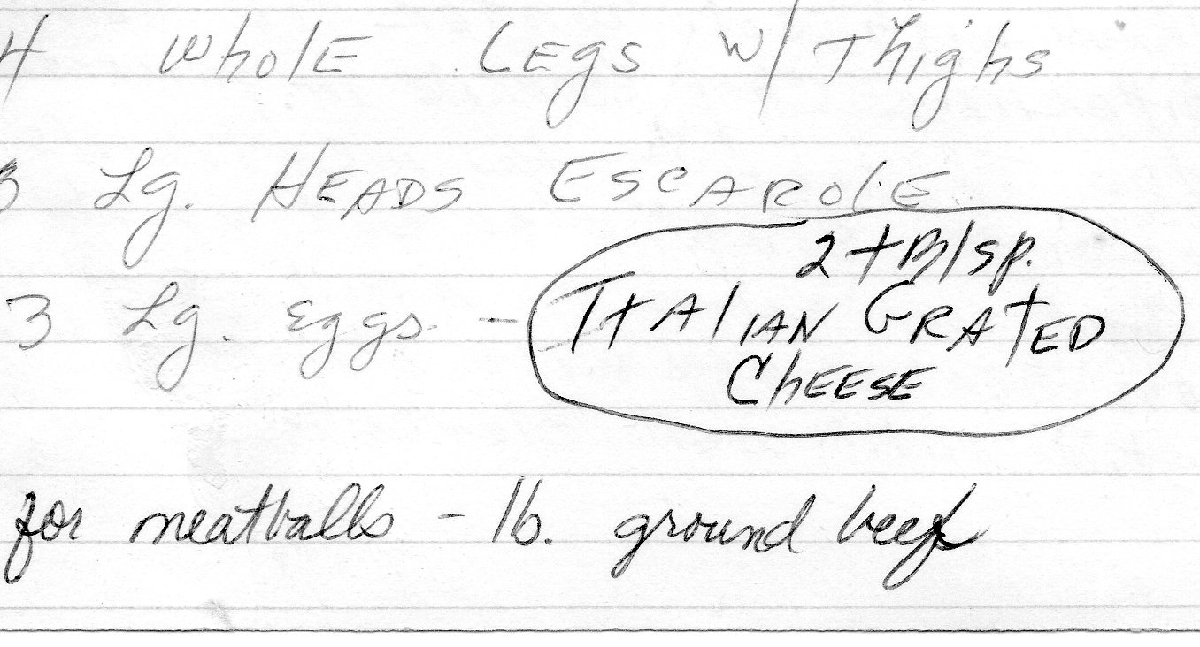

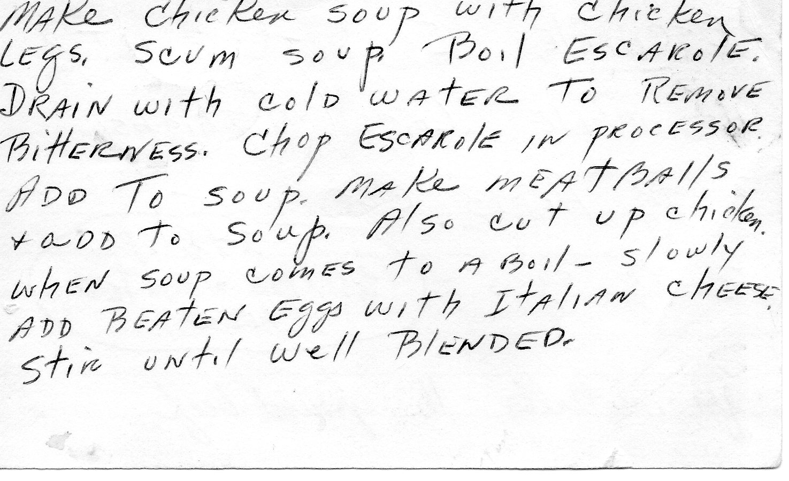

## Grandmom’s Pastine Soup

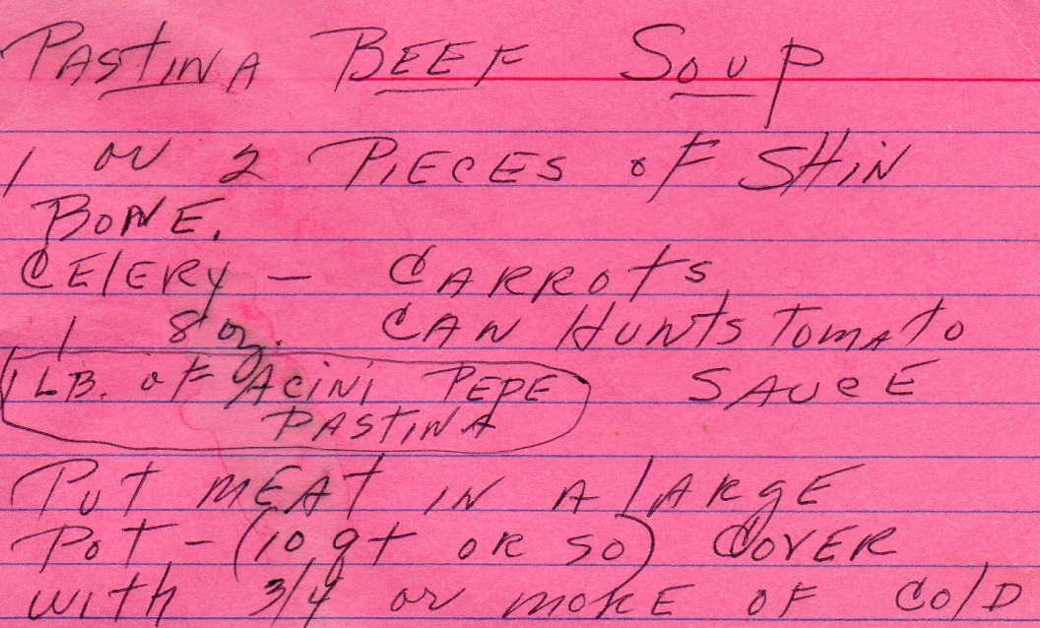

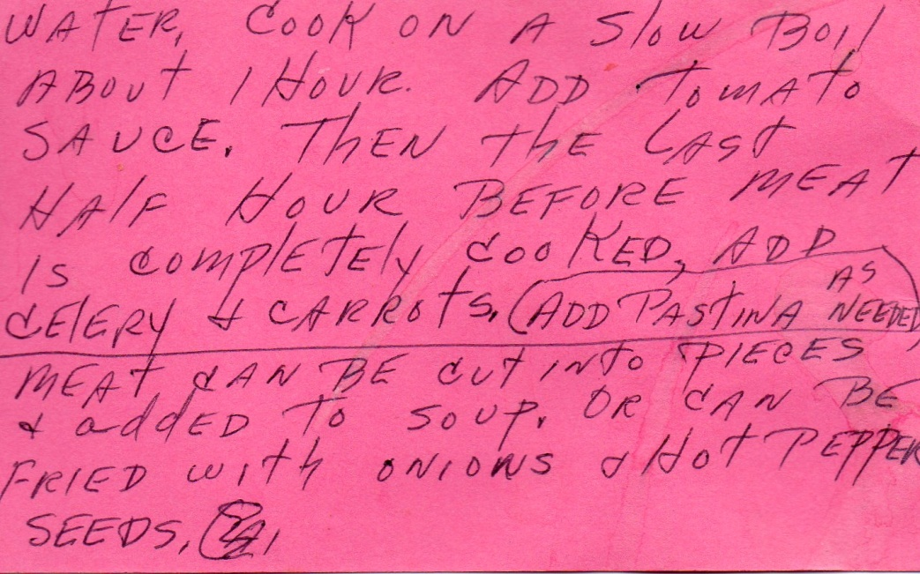

|  |  |  |  |  |  |  |  |  |  |  |  |  |  |  |  |  |  |  |  |  |
| --- | --- | --- | --- | --- | --- | --- | --- | --- | --- | --- | --- | --- | --- | --- | --- | --- | --- | --- | --- | --- |
| |  |  | | --- | --- | | Italian Sausage Soup(Adapted) |  |  |  |  |  |  |  |  | | --- | --- | --- | --- | --- | --- | | recipe image | |  |  | | --- | --- | | **Rated:** | rating |   **Submitted By:** SALLYJUN  **Photo By:** Heather   |  |  | | --- | --- | | **Prep Time:** 10 Minutes  **Cook Time:** 40 Minutes | **Ready In:** 50 Minutes  **Servings:** 6 | |   "This soup is easy to put together, and the flavor of the spicy sausage is balanced nicely by Great Northern beans, zucchini, fresh spinach, and carrots. Makes a delicious winter supper."  Ingredients:   |  |  | | --- | --- | | 1 pound Italian sausage  (1/2 lb hot, ½ lb sweet)  1-2 clove garlic, minced  2 (14 ounce) cans beef broth or  1(35 ounce) box  1 (29.5 ounce) can crushed  tomatoes  1 cup sliced carrots  1 splash of red wine | 1 (14.5 ounce) can great Northern beans,Undrained  (or canoloni beans, or 2 small potatoes)  2 small zucchini, cubed or 1 large  2 cups spinach - packed, rinsed and torn(or escarole)  1/4 teaspoon ground black pepper  1 tsp oregano  1 tsp parsley | |  |  |   Directions:   |  |  | | --- | --- | | **1.** | In a stockpot or Dutch oven, brown sausage with garlic. Stir in broth, tomatoes and carrots, and season with salt and pepper.  Add oregano and parsely. Add splash of wine. Reduce heat, cover, and simmer 15 minutes. | | **2.** | Stir in beans with liquid and zucchini. Cover, and simmer another 15 minutes, or until zucchini is tender. | | **3.** | Remove from heat, and add spinach. Replace lid allowing the heat from the soup to cook the spinach leaves. Soup is ready to serve after 5 minutes. |  |  |  | | --- | --- | | ALL RIGHTS RESERVED © 2012 Allrecipes.com | Printed from Allrecipes.com 1/15/2012 | |

[Click here to find out more!](http://ad.doubleclick.net/click;h=v8/3bfd/0/0/*/g;44306;0-0;0;12085196;2321-160/600;0/0/0;u=%5bCS%5dv1|2789728A851D2559-6000012E6028EB92%5bCE%5d;~okv=;rsi=D11170_10012;dcopt=ist;status=unrecognized;u=%5bCS%5dv1|2789728A851D2559-6000012E6028EB92%5bCE%5d;r=12942;u=1,1|2789728A851D2559-6000012E6028EB92|R12942|||||u|;tile=2;sz=160x600;bsg=106144;bsg=109729;;~aopt=2/1/d5/1;~sscs=?)

# New England Clam Chowder

4 slices bacon, chopped

1 large onion, chopped

4 medium potatoes, diced

3 cups chicken stock

1 tsp salt

½ tsp pepper

2 Tbsp butter

2 Tbsp flour

3 cups light cream

2 10 ½ cans baby clams, drained

1 cup clam juice

2 Tbsp minced parsely

Paprika

* Fry bacon in a large saucepan until crisp.
* Remove with a slotted spoon and reserve.
* Add onion to sauce pan and sauté until softened.
* Add potatoes and chicken stock.
* Season with salt and pepper, cover, and cook for 15 minutes.
* In a sauce pan, melt butter, and add flour, stirring to make a roux.
* Cook for 1 minute.
* Add light cream which has been heated.
* Cook over low heat until thickened.
* Add vegetables along with clams and clam juice.
* Garnish with parsley and paprika.

## Pumpkin Soup

From: Joan Kelly

½ c. butter

2 c. chopped onion

2 large cloves garlic, crushed

2 t. curry

1 t. salt

½ t. coriander

¼ t. cayenne pepper

6 c. ckn. broth

29 oz. can solid pack pumpkin

2 c. half and half

* Combine butter with onion and garlic in large pot.
* Saute until onions are soft.
* Add spices.
* Cook one minute.
* Add broth.
* Boil gently uncovered 15-20 minutes.
* Stir in pumpkin and half and half.
* Cool very well. Then blend in blender until creamy.
* Heat up and serve hot.

## Stuffed Pepper Soup

(adapted from allRecipes)

Prep Time: 10 Minutes

Cook Time: 1 hour 5 minuutes

Serves :8

2 cups chopped onion

1/2 cup chopped celery

2 cloves garlic, minced

4 cups chopped green bell pepper(about 2 peppers)

¼ cup vegetable oil

1 pound ground turkey

2(16 ounce cans crushed tomatoes)

1 cup tomato sauce

½ cup uncooked white rice

6 cups beef broth

¼ cup chopped fresh parsely

1 tbl and tsp white sugar

2 tsp salt

2 tsp ground black pepper

½ tbls dried thyme

* Saute onion, celery, garlic, and green pepper in oil until just tender.
  + Do not brown.
* Stir beef into vegetables, cook until turkey is browned(about 10 minutes).
* Stir in rice.
* Add tomatoes, tomato sauce, salsa, beef broth, parsely, sugar, thyme, salt, and pepper to the browned turkey mixture.
* Cover and simmer 45 minutes until rice is cooked. Adjust liquid if necessary.
* Garnish with a parsely sprig.

## Thai Tom Kha Gai

Serves: 6

Prep: 20 minutes

Cooking Time: 15 minutes

4 cups chicken broth

2 pieces(about 4 inches long) lemongrass, root end crushed

1 inch piece of fresh ginger, peeled and thinly sliced.

3 cloves garlic, minced

1 package(8 ounces) sliced mushrooms

4 Tbls Sriracha sauce

1 lb. broccoli florets

¾ lb bonless chicken breasts, cut into 1/2 inch pieces

1 sweet red pepper, cut into matchstick pieces

1 can(14 ounces) coconut milk

¼ cup fresh lime juice

1 Tbls fish sauce

Slice scallions optional

* 1. Heat chicken broth in a large pot over medium-high heat.
  2. Add lemongrass and ginger.
  3. Simmer for 5 minutes until fragrant.
  4. Add garlic, mushrooms, and chile sauce.
  5. Cover and cook for 5 more minutes.
  6. Stir in broccoli, chicken, and sweet red pepper, and coconut milk.
  7. Simmer for five minutes until chicken is cooked through.
  8. Remove from heat and add lime juice and fish sauce.
  9. Ladle into bowl and top with scallions if desired.

## Vegetarian Chili

* **Prep Time:** 15 mins
* **Total Time:** 60 minutes
* **Servings:** 8

Ingredients

* + 2 (15 ounce) cans kidney beans, drained and rinsed
  + 1 (15 ounce) cans black beans, drained and rinsed 1 (16 ounce) cans vegetarian baked beans
  + 1 large 29 oz. can crushed tomatoes
  + 1 can stewed or diced tomatoes
  + 1 (15 ounce) cans whole kernel corn, drained
  + 1 onion, chopped
  + 1 green bell peppers, chopped
  + 1 red bell pepper, chopped
  + 1 large zucchini, chopped
  + 3 stalks celery, chopped
  + 1 large carrot
  + ½ lb Portobello mushroom caps, chopped
  + 2 garlic cloves, chopped
  + 1 (4 ounce) cans diced chilies
  + 2 jalapenos, diced fine
  + 2 tablespoon chili powder
  + 1 teaspoons cumin
  + ¼ tsp cayenne pepper
  + 1 tablespoon dried parsley or 2-3 Tbls fresh chopped parsely
  + 1-2 tbls flour
  + ½ cup of red wine

Directions

1. In a saucepan, saute the onion, bell peppers, garlic, carrots, jalapeno peppers, and celery for about 3 minutes.
2. Add flour to make a roux. Stir for another minute.
3. Add mushrooms and zucchini. Stir for another 2 minutes.
4. Add beans, crushed tomatoes, stewed or diced tomatoes, chili peppers, corn, chili powder, cumin cayenne pepper, parsely, and red wine.
5. Bring to a boil, then simmer for 20 minutes.
6. Can top with cheddar cheese or sour cream.

# SAUCES & DRESSINGS

C:\Users\Laurey\AppData\Local\Microsoft\Windows\Temporary Internet Files\Content.IE5\N7HF1BQN\MC900199327[1].wmf

## Alfredo Sauce

Serves: 4

1/4 pound unsalted butter(1 stick), melted  
1 cup heavy cream, warmed  
3/4 cup freshly grated Parmesan cheese or 2/3 cup locatello cheese  
Salt to taste  
1/4 teaspoon freshly ground pepper  
  
Melt butter in a pan, add heavy cream and cheese, stirring until thick. Season with salt and pepper. Can serve alone, or add vegetables(for pasta primavera, and/or cooked chicken). Serve over ½ pound of pasta.

## Horseradish Cream Sauce

Recipe courtesy Alton Brown, 2004

Prep Time:

10 min

Inactive Prep Time:

4 hr 0 min

Level:

Easy

Serves:

approximately 1 1/4 cups

Ingredients

* 1 cup sour cream
* 1/4 cup grated fresh [horseradish](http://www.foodterms.com/encyclopedia/horseradish/index.html)
* 1 tablespoon [Dijon mustard](http://www.foodterms.com/encyclopedia/dijon-mustard/index.html)
* 1 teaspoon [white wine vinegar](http://www.foodterms.com/encyclopedia/vinegar/index.html)
* 1/2 teaspoon kosher salt
* 1/4 teaspoon freshly ground black pepper

Can substitute the Dijon mustard and white wine with 1/8 tsp Worcester sauce

Directions

* If using store bought horseradish sauce should press out vinegar before using. If too vinegary add some cream.
* Place all of the ingredients into a medium mixing bowl and whisk until the mixture is smooth and creamy.
* Place in the refrigerator for at least 4 hours or overnight to allow flavors to meld.
* Sauce can be stored in the refrigerator in an airtight container for 2 to 3 weeks.

## Spinach Salad Dressing

From: Beau Rivage

1 tsp grated onion

1 tsp salt

½ tsp pepper

2 Tbls honey mustard

2 Tbls wine vinegar

8 Tbls oil

½ tsp lemon juice

* Combine onion, salt, and mustard in mixing bowl.
* Add vinegar.
* Beat oil in 1 Tbls at a time until smooth.
* Stir in lemon juice.

# VEGETABLES

## C:\Users\Laurey\AppData\Local\Microsoft\Windows\Temporary Internet Files\Content.IE5\N7HF1BQN\MC900441872[1].wmf

## Asparagus

### Minute Asparagus

From: James Beard(Adapted)

2 pounds of asparagus

Salt

¼ pound unsalted butter(can use 2 tbls butter and some olive oil for a more heart friendly version)

3 Tbls soy sauce

1 Tbls lemon juice

Freshly ground pepper

* Wash and trim the asparagus.
* Cut into diagonal slices no more than ¼ inch thick-thinner if possible.
* Place the slices in a steamer basket and steam until just tender(about one minute).
* To the side combine soy sauce lemon juice and pepper.
* Melt the butter in a large skillet.
* Add soy sauce combination to butter and wait until browned.
* Add asparagus(can do this in previous step if desired).

|  |  |
| --- | --- |
| BrocolliRoasted Garlic Lemon Broccoli |  |

|  |  |  |  |  |  |
| --- | --- | --- | --- | --- | --- |
| recipe image | |  |  | | --- | --- | | **Rated:** | rating |   **From:** AllRecipe.com(adapted)  **Photo By:** TTV78   |  |  | | --- | --- | | **Prep Time:** 10 Minutes  **Cook Time:** 15 Minutes | **Ready In:** 25 Minutes  **Servings:** 12 | |

* "Broccoli florets are roasted after being tossed in olive oil and sprinkled with sea salt, freshly ground black pepper, and minced garlic. A squeeze of lemon juice before serving seals the deal."

**Ingredients:**

|  |  |
| --- | --- |
| 4 heads broccoli, separated into florets  1 tablespoon and 1 teaspoon extra-virgin  olive oil  small amount of salt  montreal seasoning(optional) | 1 teaspoon ground black pepper  2 cloves garlic, minced  1 teaspoon lemon juice- or instead of lemon juice could try roasted red peppers, parsely and top with bread crumbs and parmesian cheese. |

|  |  |
| --- | --- |
|  | * Preheat the oven to 400 degrees F (200 degrees C). |
|  | * In a large bowl, toss broccoli florets with the extra virgin olive oil, sea salt, pepper and garlic(montreal seasoning if desired). Spread the broccoli out in an even layer on a baking sheet. * Can top with roasted red peppers, parsely, bread crumbs, and parmesian cheese if not going to do the lemon recipe. |
|  | * Bake in the preheated oven until florets are tender enough to pierce the stems with a fork, 15 to 20 minutes. Remove and transfer to a serving platter. * Squeeze lemon juice liberally over the broccoli before serving for a refreshing, tangy finish. |

## Brocolli Salad

4 big bunches of broccoli

1 lb of bacon

½ cup of raisins

3 cups of mayo

¾ cup of sugar

2 Tbls vinegar

Chop off broccoli florets, wash, and put in bowl.

Fry 1 lb of bacon(or microwave), then crumble.

Mix mayo, sugar, and vinegar in separate bowl.

Pour over broccoli florets, and bacon and raisins and mix well.

### Dad’s Secret Brocolli Recipe

(Christopher once told the lady in ShopRite that his dad had a secret recipe for broccoli and proceeded to tell her just how to cook it)

Brocolli

Italian seasoned bread crumbs

Locatella cheese

Cut the broccoli into florets.

Steam in a vegetable steamer.

Pour into plate and top with bread crumbs and locatella cheese

## **Brussel Sprouts**

### **Tin Roof Brussel Sprouts**

**Good pictures of this being cooked at :**

<http://gourmetcentric.com/2011/03/tin-roof-bistro-brussels-sprouts.php>

**Ingredients:**

1 pound Brussels sprouts

3 tablespoons butter

3 Tb extra virgin olive oil

1 tsp minced garlic

1 tsp minced anchovy

1-2 teaspoons whole capers

1 Tb lemon juice

1 tsp parsley chopped (optional)

Salt and pepper to taste

**Cooking method:**

Prep the Brussels sprouts by removing root end and rough outer leaves.  Cut in half lengthwise.  Put in bowl and add 2 tablespoons of extra virgin olive oil.  Toss Brussels sprouts in oil, then lay out on sheet pan.  Roast for 20-25 minutes in oven at 350 degrees F. until lightly caramelized.  When Brussels sprouts are roasted, heat up small sauté pan.  Add 3 tablespoons of butter.  Allow to melt.  Add minced garlic and anchovy.  Cook for several minutes until garlic turns a golden color.  Add lemon juice, capers, parsley and salt & pepper.  Toss sprouts in sauce until thoroughly coated.

It goes well served over grilled ciabatta bread.  To grill the bread, brush ciabatta with 1 tablespoon of extra virgin olive oil, and then grill or toast the bread.  Place the grilled ciabatta in bottom of a bowl and pour the Brussels sprouts over the bread.

Serves 2

|  |  |
| --- | --- |
| CabbageSweet Restaurant Slaw |  |

|  |  |  |  |  |  |
| --- | --- | --- | --- | --- | --- |
| recipe image | |  |  | | --- | --- | | **Rated:** | rating |   **Submitted By:** Sandi Johnson(adapted)  **Photo By:** CookinBug   |  |  | | --- | --- | | **Prep Time:** 15 Minutes | **Ready In:** 2 Hours 15 Minutes  **Servings:** 8 | |

"Easy to make with convenient, packaged coleslaw, in this version the creamy dressing with vinegar, sugar and vegetable oil is close to what's served at popular fried chicken, burger and fish restaurants."

**Ingredients:**

|  |  |
| --- | --- |
| 1 (16 ounce) bag coleslaw mix  --** or ½ small head of chopped cabbage  1 tsp onion, minced  2/3 cup Mayonnaise  1/3 cup sour cream | 1/4 cup white sugar  1 tablespoon white vinegar  1/4 teaspoon salt  1/2 teaspoon celery seeds |

**Directions:**

If using head of cabbage chop in food processor. Can add a carrots for color if desired.

|  |  |
| --- | --- |
| **1.** | Combine the coleslaw mix and onion in a large bowl. |
| **2.** | Whisk together the salad dressing, sour cream, sugar, vinegar, salt, and poppy seeds in a medium bowl; blend thoroughly. Pour dressing mixture over coleslaw mix and toss to coat. Chill at least 2 hours before serving. |

|  |  |
| --- | --- |
| ALL RIGHTS RESERVED © 2011 Allrecipes.com | Printed from Allrecipes.com 12/10/2011 |

## Carrots

### Carrots and Apples Sauteed in Vodka

From: Julia Rosenberg

1 pound of carrots

1 apple

2-4 Tbls butter

Salt and pepper to taste

¼ cup vodka and equal amount water

Peel and slice carrots.

Core and slice apple into thin pieces(I use a granny apple).

In a skillet sautee carrots and apples in butter over medium heat until tender crisp.

Add salt and pepper to taste.

Add vodka and water and cook until carrots are tender and most of the liquid is absorbed.

## Green Beans

### Green Bean Supreme

From: Julia Rosenberg

Serves: 6-8

½ cup sliced onions

2 Tbls butter

2 Tbls flour

1 tsp salt

¼ tsp pepper

½ cup shredded sharp cheese

½ tsp grated lemon peel

1 Tbls chopped parsley

1 cup sour cream

5 cups cooked drained beans

½ cup buttered bread crumbs

* Cook onion in butter until golden.
* Add flour, salt, pepper, lemon peel, and parsley.
* Cook and stir until mixture bubbles.
* Blend in sour cream.
* Add beans, heat through stirring constantly.
* Put in baking dish or casserole.
* Top with cheese and then bread crumbs.
* Broil until cheese melts and crumbs turn brown.

## Peas

### Peas with Shallots and Pancetta

Recipe courtesy Bobby Flay

Prep Time: 5 min

Cook Time: 15 min

Level: Easy

Serves: 4 servings

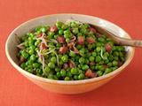

Ingredients

* 2 tablespoons [olive oil](http://www.foodterms.com/encyclopedia/olive-oil/index.html)
* 1/2 pound pancetta, cut into small dice
* 3 shallots, halved and thinly sliced
* Pinch red pepper flakes
* 1 pound frozen peas, thawed

Directions

Heat the oil in a large high sided saute pan over medium heat. Add the pancetta and cook until golden brown and the fat has rendered. Remove the [pancetta](http://www.foodterms.com/encyclopedia/pancetta/index.html) to a plate lined with paper towels.

Add the [shallots](http://www.foodterms.com/encyclopedia/shallot/index.html) and [red pepper flakes](http://www.foodterms.com/encyclopedia/red-pepper-flakes/index.html) to the pan and cook until soft. Add the peas and cook until warmed through. Transfer to a large bowl and top with the crisp pancetta.

## **Potatos**

### **Roasted Sweet Potatoes with Maple Syrup, Orange and Spices**

**(From Gwyneth Paltrow)**  
These sweet potatoes get sticky and sweet, full of great holiday flavor.

SERVES: 12  
TIME: a little less than an hour, largely unattended

* 3 3/4 pounds sweet potatoes, peeled  
* 1 1/4 cup real Vermont maple syrup  
* 1/4 cup vegetable oil  
* 1 1/4 teaspoons ground cinnamon  
* 1/2 teaspoon ground cloves  
* 1 large orange  
* 3 star anises or 1 tsp crushed star anise seeds (I ground the seeds in a spice mill after measuring)

Preheat the oven to 375º F.

Cut each sweet potato in half horizontally and then cut each half into 1/3 planks (about four slices per half depending on the size of the sweet potato). Lay the sweet potatoes in a single layer in one large or two medium baking dishes (two 13 x 9 dishes will do the job).

Mix the maple syrup, vegetable oil, cinnamon and cloves together in a small bowl. Peel off four large strips of zest from the orange. Cut the orange in half and squeeze the juice into the bowl with the maple syrup mixture. Pour this mixture evenly over the sweet potatoes, nestle in the strips of zest and the star anise. Bake for 45 minutes or until the sweet potatoes are soft and saturated.

## Zuccini

### Grandmom’s Zucchini Fritters

1 zucchini(large)

1 egg

Bread crumbs

Locatello cheese

Salt and pepper

Onion

Oregano

Basil

* Peel and grate zucchini.
* Combine zucchini, egg, bread crumbs, cheese, salt and pepper, onion, oregano, and basil.
* Drop in spoonfuls in frying pan until brown on both sides.

## Zucchini Medley

1 green zucchini

1 yellow zuccini

3 plum tomatoes

½ medium onion(sliced)

2 garlic cloves

½ tsp marjoram

Salt

Pepper

1 Tbls olive oil

Slice zuccini’s and onions thin.

Cut the tomatoes in half the long way and then chop in about ½ inch pieces.

Heat olive oil in a frying pan.

Put garlic cloves through a garlic press and stir until fragrant.

Add the onions and stir until soft(3-5 minutes)

Add the tomatoes and stir until soft(5 minutes)

Add the zucchini, marjoram, salt and peper to taste.

Stir until the zucchini just starts to soften.

# EGG DISHES

# C:\Users\Laurey\AppData\Local\Microsoft\Windows\Temporary Internet Files\Content.IE5\2NTOEIH9\MP900402816[1].jpg

## Grandmom’s Sausage Egg Quiche

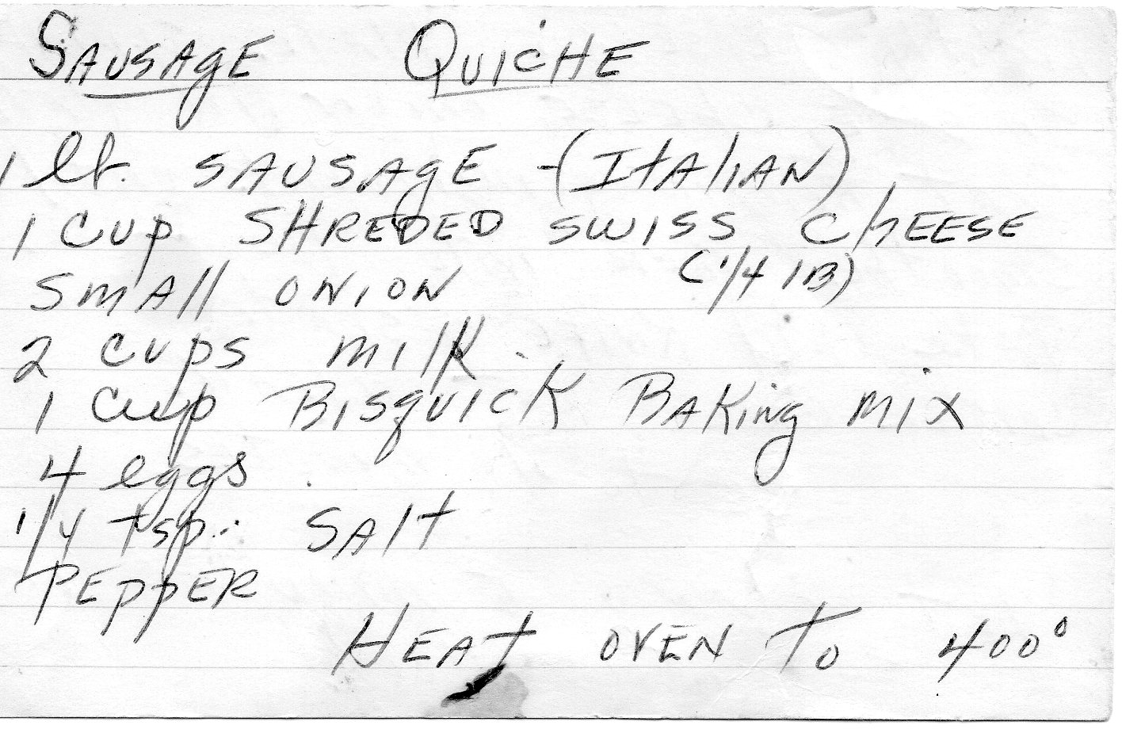

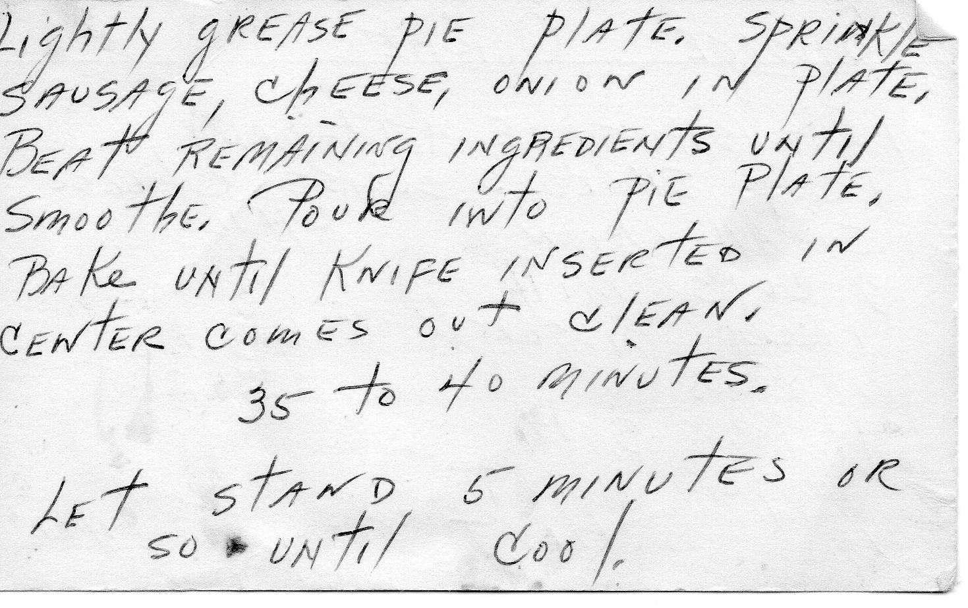

|  |  |
| --- | --- |
| Sausage Egg Casserole |  |

|  |  |  |  |  |  |
| --- | --- | --- | --- | --- | --- |
| recipe image | |  |  | | --- | --- | | **Rated:** | rating |   **Submitted By:** KNITWIT  **Photo By:** Sheri O.   |  |  | | --- | --- | | **Prep Time:** 20 Minutes  **Cook Time:** 1 Hour 20 Minutes | **Ready In:** 9 Hours 40 Minutes  **Servings:** 12 | |

"Assemble the ingredients the night before, and bake this casserole in the morning. Stand back and wait for the compliments. I've made it with fat free cottage cheese, egg substitute, and reduced fat sausage; the taste is still wonderful!"

(modified)

**Ingredients:**

|  |  |
| --- | --- |
| 3/4 pound ground pork sausage  1 tablespoon butter  4 green onions, chopped  10 eggs, beaten  1 (16 ounce) container low-fat cottage  cheese  1 pound Monterey Jack cheese, | shredded  2 (4 ounce) cans diced green chile  peppers, drained    1 cup all-purpose flour  1 teaspoon baking powder  1/2 teaspoon salt  1/3 cup butter, melted |

**Directions:**

|  |  |
| --- | --- |
| **1.** | Place sausage in a large, deep skillet. Cook over medium-high heat until evenly brown. Drain, and set aside. Melt butter in skillet, and cook and stir the green onions and mushrooms until tender. |
| **2.** | In a large bowl, mix the eggs, cottage cheese, Monterey Jack cheese, and chiles. Stir in the sausage, green onions, and mushrooms. Cover, and refrigerate overnight. |
| **3.** | Preheat oven to 350 degrees F (175 degrees C). Lightly grease a 9x13 inch baking dish. |
| **4.** | In a bowl, sift together the flour, baking powder, and salt. Blend in the melted butter. Stir the flour mixture into the egg mixture. Pour into the prepared baking dish. |
| **5.** | Bake 40 to 50 minutes in the preheated oven, or until lightly brown. Let stand 10 minutes before serving. |

|  |  |
| --- | --- |
| ALL RIGHTS RESERVED © 2011 Allrecipes.com | Printed from Allrecipes.com 12/24/2011 |

## Grandmom’s Zuccini Casserole

1 ½ cup bisquick mix

3-4 zuccini cubed (do not peel)

½ lb mushrooms(optional)

1 tsp basil leaves

½ cup vegetable oil

3 eggs beaten

1 onion

1 tsp oregano

Salt and Pepper to taste

Parmesan cheese, just a sprinkle

Grease 1 ½ quart casserole.

Mix ingredients in casserole.

Bake at 400 for 30-40 minutes

# PASTA

C:\Users\Laurey\AppData\Local\Microsoft\Windows\Temporary Internet Files\Content.IE5\2NTOEIH9\MC900411019[1].wmf

## Pasta Della Momma

1/4 pound unsalted butter(1 stick), melted  
1 cup heavy cream, warmed  
3/4 cup freshly grated Parmesan cheese or 2/3 cup locatello cheese  
Salt to taste  
1/4 teaspoon freshly ground pepper

Shredded Mozzarella cheese

Frozen peas

Prosciutte or ham end

1 bag of frozen Tortellini  
  
Preheat oven to 350.

* Cook tortellini following instructions on bag.
* Meanwhile, melt butter in a pan, add heavy cream and cheese, stirring until thick.
* Season with salt and pepper.
* Place the tortellini in a small casserole dish.
* Mix in the alfredo sauce, frozen peas, mozzarella, and meat.
* Place in preheated oven for about ½ an hour.

## 

## Pasta In Pepper Sauce

From: 365 Easy Italian recipes

Prep Time: 10 Minutes

Cook Time: 30 to 40 minutes

Serves:4-6

2 Tbl olive oil

2 garlic cloves

1 medium green bell pepper cut into strips

1 medium red bell pepper cut into strips

1 30 ounce can Italian crushed tomatoes in puree

3 Tbl chopped fresh basil or 2 tsp dried

2 Tbl chopped fresh parsely

1 cup water

¾ tsp salt

¼ tsp pepper

1 pound ziti

Grated romano cheese

* In a nonreactive large saucepan, heat olive oil over medium heat.
* Add garlic and cook 30 seconds, or until fragrant being careful not to burn.
* Add peppers and cook, stirring occasionally, 3 to 4 minutes, or until bright in color and slightly softened.
* Add tomatoes with puree, basil, parsley, water, salt, and pepper.
* Bring to a boil over medium-high heat. Reduce heat to medium and cook partially covered 20 to 30 minutes, until thickened. Add a little water if sauce becomes too thick.
* When sauce is almost ready, cook in a large pot of boiling salted water until tender but still firm, 10 to 12 minutes; drain.
* Pour pasta and sauce into a warmed large bowl and toss together.
* Pass a bowl of Romano cheese on the side.

## Stuffed Shells

1 pkg(12 oz) jumbo shells

4 cups (2 lb) ricotta cheese

2 cups(8 oz) shredded mozzarella

½ cup grated parmesan cheese

2 eggs

1 Tbls chopped fresh parsley

½ tsp salt

¼ tsp ground pepper

1/8 tsp nutmeg

3 cups spaghetti sauce

* Heat oven to 375 degrees
* Cook pasta according to the directions
* Mix together ricotta, mozzarella, parmesan cheese, eggs, parsley, salt, pepper, and nutmeg.
* Fill each shell with about 1 Tbls sauce.
* Spread ½ cup spaghetti sauce in bottom of baking dish.
* Layer shells over sauce.
* Spread remaining sauce over shells. Sprinkle with parmesan cheese.
* Cover with foil and bake for 40 minutes.

(can freeze shells before cooking )

# BEEF

C:\Users\Laurey\AppData\Local\Microsoft\Windows\Temporary Internet Files\Content.IE5\2NTOEIH9\MC900023731[1].wmf C:\Users\Laurey\AppData\Local\Microsoft\Windows\Temporary Internet Files\Content.IE5\2RH9L8EI\MC900013333[1].wmfC:\Users\Laurey\AppData\Local\Microsoft\Windows\Temporary Internet Files\Content.IE5\N7HF1BQN\MC900030348[1].wmf

## Flemish Pot Roast

From James Beard(adapted)

This recipe also works well in a crock pot.

3 large onions

2 Tbls oil

3 Tbls butter

1 tsp thyme

1 bay leaf

1 pint of beer

2 heaping Tbls sour cream

Salt

Pepper

Brown beef on all sides in oil and remove from pan.

Slice onions and sauté in butter until limp and golden.

Season with salt and pepper

Put in deep pan with browned beef, thyme, bay leaf , and beer.

Cover and simmer until tender.

Remove meat, adjust seasoning, add sour cream, and serve over the sliced beef.

Serve over parsleyed potatoes, buttered egg noodles or spaetzle.

# PORK



|  |  |
| --- | --- |
| Pork Chops with Fresh Tomato, Onion, Garlic, and Feta |  |

|  |  |  |  |  |  |
| --- | --- | --- | --- | --- | --- |
| recipe image | |  |  | | --- | --- | | **Rated:** | rating |   **Submitted By:** Lovecooking  **Photo By:** Schwammrs   |  |  | | --- | --- | | **Prep Time:** 15 Minutes  **Cook Time:** 20 Minutes | **Ready In:** 35 Minutes  **Servings:** 4 | |

"You will not be disappointed with this wonderful pork chop. It is tender, moist, and full of fresh flavors. I serve with garlic mashed potatoes and asparagus. It’s also good with thin sliced chicken breasts.

**Ingredients:**

|  |  |
| --- | --- |
| 2 tablespoons olive oil, divided  1 large onion, halved and thinly sliced  4 pork loin chops, 1 inch thick  salt to taste  black pepper to taste  garlic powder to taste | 1/2 pint red grape tomatoes, halved  1/2 pint yellow grape tomatoes, halved  3 cloves garlic, diced  1 tablespoon dried basil(or 3TBL fresh basil)  2 1/2 teaspoons balsamic vinegar  4 ounces feta cheese, crumbled |

**Directions:**

|  |  |
| --- | --- |
| **1.** | Heat 1 tablespoon oil in a skillet over medium heat. Stir in the onion and cook until golden brown. Set aside. |
| **2.** | Heat 1/2 tablespoon oil in the skillet. Season pork chops with salt, pepper, and garlic powder, and place in the skillet. Cook to desired doneness. Set aside and keep warm.(reviewers said to sear to brown on both sides and finish baking in low oven while cooking the test to keep it moist 300) |
| **3.** | Heat remaining oil in the skillet. Return onions to skillet, and stir in tomatoes, garlic, and basil. Cook and stir about 3 minutes, until tomatoes are tender. Mix in balsamic vinegar, and season with salt and pepper. Top chops with the onion and tomato mixture, and sprinkle with feta cheese to serve. When using fresh basil add at the end. Can cover for five minute with topping on pork chops to melt feta cheese a little.  Some people said to braise the pork chops with the onions until reduced by half.  Reviewers also said this was good with chicken. |

Pork Goulash

Makes: 6 servings

Prep: 15 minutes

Cook: 1 hour ten minutes

Adapted: From Family Circle

Tip: Served over egg noodles.

3 pounds of pork roast(cut into 1 ½ pieces)

3 Tbls all-purpose flour

2 Tbls sweet Hungarian paprika

½ tsp salt

3 Tbls vegetable oil

1 medium onion, chopped

1 sweet red pepper, cored and diced

3 Tbls. Apple cider vinegar

½ tsp marjoram

1 can(14.5 oz) diced tomatoes

1 cup of beef broth

2 Tbls tomato paste

1/2 cup of beer

2 Tbls sour cream

1Tbls chopped fresh parsely

* + 1. In a large bowl, combine pork, 2 Tbls of flour, 1 Tbls of paprika and ¼ tsp salt.
    2. Heat 1 ½ tsp oil in a large Dutch oven over medium-high heat. Add half the pork and brown on all sides(about 5 minutes). Remove meat and repeat with other ½ of meat.
    3. Reduce heat to medium(meat not in pan), add the onion and cook for 3 minutes.
    4. Add the red pepper and cook for 2 minutes.
    5. Sprinkle with remaining Tbls each of flour and paprika. Cook for 1 more minute.
    6. Stir in vinegar and marjoram , and let simmer.
    7. Add tomatoes, broth, and beer- scraping any brown bits from pan.
    8. Add pork. Cover and simmer over low heat for 1 hour.
    9. Stir in tomato paste and remaining salt. Simmer for 10 more minutes.
    10. Mix in sour cream and sprinkle with parsley.
    11. Serve over egg noodles.

## Marinated Grilled Pork

3 pounds of pork loin

¾ cup of chipotle salsa

¼ cup of honey

¼ cup of lime juice

½ cup of orange juice

1 minced clove

½ tsp fresh ground pepper

Optional 1 tbls fresh chopped parsley or cilantro

* Combine ingredients and marinate for 3-6 hours. Grill or bake in a 350 degree oven until done.
* Use half marinade to brush on as the pork is cooking.
* Use remaining half of marinade to make a sauce. Make a roux to thicken. Boil marinade thoroughly to cook any of the juices from the pork. Can add spices, wine or chicken broth to the sauce as desired.
* Leftovers make great fajitas.

C:\Users\Laurey\AppData\Local\Microsoft\Windows\Temporary Internet Files\Content.IE5\2RH9L8EI\MC900413686[1].wmf

# CHICKEN



## Chicken Enchiladas

1/2 yellow onion, [diced small](http://www.thekitchn.com/thekitchn/video/how-to-dice-an-onion-the-video-048681)  
1/2 bell pepper, [diced small](http://www.thekitchn.com/thekitchn/how-to/how-to-slice-a-bell-pepper-113964) (any color)  
1 16-ounce can black beans, drained and rinsed  
1 can corn

1 can enchilada sauce

½ cup tomato sauce

1 can chipotle peppers in adobo sauce  
2 teaspoons [chili powder](http://www.thekitchn.com/thekitchn/spice-mix/from-the-spice-cupboard-chili-powder-126876)  
1 teaspoon [cumin](http://www.thekitchn.com/thekitchn/seasonings/from-the-spice-cupboard-cumin-067449)

4 chicken breasts

1 ½ cups cheese

Tortillas

* Sauté onion and bell pepper in pot.
* Add remaining ingredients and simmer for 10-15 minutes.
* Remove chicken breasts and shred.
* Return to pot and simmer for 20 more minutes.
* Heat tortillas
* In each tortilla add chicken and cheese
* Layer the rolled tortillas in a 9x13 baking pan, cover with remaining sauce and cover with aluminum foil.
* Bake at 400 degrees for 20 minutes.
* Uncover and sprinkle with cheese and bake uncovered for an addition 5-10 minutes.

## Green Thai Curry

1 can Thai coconut milk

1/3 cup fresh basil

3 TBL Thai fish sauce

1/3 cup chicken stock

Vegetables of your choice-ex. Green beans, red peppers, green peppers, bamboo shoots.

* Simmer curry paste and solid part of coconut milk until boiling(about 2 minutes).
* Add rest of coconut milk and bring to a boil.
* Add remaining ingredients including meat and vegetables of your choice.

### 

## Margarita Chicken Breasts

Serves:4

Marinade:

¼ cup fresh lime juice

¼ cup extra virgin olive oil

2 Tbls tequila

1 tsp kosher salt

1 tsp grated lime zest

¼ tsp cayenne

4 boneless chicken breast halves

* Whisk together marinade ingredients.
* Rinse chicken breasts under cold water and pat dry with paper towles.
* Place in large plastic bag and pour in marinade
* Press the air out of the bag and seal tightly.
* Turn bag to distribute the marinade, place in a bowl, and regregerate for about 1 hour.
* Remove the breasts from the bag and reserve the marinade. Pour the marinade into a small saucepan, and bring to a boil for 1 full minute.
* Grill the breasts over direct medium heat until the juices run clear and the meat is no longer pink in the center, 8 to 12 minutes, turning and basting with the marinade once halfway through the grilling time.
* Serve warm

# FISH

|  |  |  |  |  |  |  |  |  |  |  |  |  |  |  |  |  |  |  |  |  |  |  |
| --- | --- | --- | --- | --- | --- | --- | --- | --- | --- | --- | --- | --- | --- | --- | --- | --- | --- | --- | --- | --- | --- | --- |
| |  |  |  |  |  |  |  |  |  |  |  |  |  |  |  |  |  |  |  |  |  | | --- | --- | --- | --- | --- | --- | --- | --- | --- | --- | --- | --- | --- | --- | --- | --- | --- | --- | --- | --- | --- | | |  |  | | --- | --- | | Grilled Fish Tacos with Chipotle-Lime Dressing |  |  |  |  |  |  |  |  | | --- | --- | --- | --- | --- | --- | | recipe image | |  |  | | --- | --- | | **Rated:** | rating |   **Submitted By:** mabcat  **Photo By:** jrbaker   |  |  | | --- | --- | | **Prep Time:** 35 Minutes  **Cook Time:** 9 Minutes | **Ready In:** 6 Hours 44 Minutes  **Servings:** 6 | |   "Inspired by a Mexican favorite, grilled fish tacos have a creamy dressing spiked with lime juice, cumin, chili powder, and adobo sauce from zesty chipotle peppers. Garnished with tomatoes, cilantro, shredded cabbage, and lime wedges, these tacos are guaranteed delicious."  **Ingredients:**   |  |  | | --- | --- | | Marinade  1/4 cup extra virgin olive oil  2 tablespoons distilled white vinegar  2 tablespoons fresh lime juice  2 teaspoons lime zest  1 1/2 teaspoons honey  2 cloves garlic, minced  1/2 teaspoon cumin  1/2 teaspoon chili powder  1 teaspoon seafood seasoning, such as  Old Bay™  1/2 teaspoon ground black pepper  1 teaspoon hot pepper sauce, or to taste  1 pound tilapia fillets, cut into chunks    Dressing  1 (8 ounce) container light sour cream | 1/2 cup adobo sauce from chipotle  peppers  2 tablespoons fresh lime juice  2 teaspoons lime zest  1/4 teaspoon cumin  1/4 teaspoon chili powder  1/2 teaspoon seafood seasoning, such  as Old Bay™  salt and pepper to taste    Toppings  1 (10 ounce) package tortillas  3 ripe tomatoes, seeded and diced  1 bunch cilantro, chopped  1 small head cabbage, cored and  shredded  2 limes, cut in wedges |   **Directions:**   |  |  | | --- | --- | | **1.** | To make the marinade, whisk together the olive oil, vinegar, lime juice, lime zest, honey, garlic, cumin, chili powder, seafood seasoning, black pepper, and hot sauce in a bowl until blended. Place the tilapia in a shallow dish, and pour the marinade over the fish. Cover, and refrigerate 6 to 8 hours. | | **2.** | To make the dressing, combine the sour cream and adobo sauce in a bowl. Stir in the lime juice, lime zest, cumin, chili powder, seafood seasoning. Add salt, and pepper in desired amounts. Cover, and refrigerate until needed. | | **3.** | Preheat an outdoor grill for high heat and lightly oil grate. Set grate 4 inches from the heat. | | **4.** | Remove fish from marinade, drain off any excess and discard marinade. Grill fish pieces until easily flaked with a fork, turning once, about 9 minutes. | | **5.** | Assemble tacos by placing fish pieces in the center of tortillas with desired | | | [http://s0.2mdn.net/1792905/4-12RV_HEADLINE_STD_NATL_160_600_Bluetooth.jpg](http://ad.doubleclick.net/click;h=v8/3c6d/3/0/*/k;256724135;0-0;0;79460392;2321-160/600;47957469/47972447/1;u=%5BCS%5Dv1|27D3446F051D0AD1-600001068001CC1C%5BCE%5D;~okv=;pc=DFP255909913;;~aopt=0/ff/d5/ff;~fdr=255909913;0-0;0;12085196;2321-160/600;47945448/47960441/1;u=%5bCS%5dv1|27D3446F051D0AD1-600001068001CC1C%5bCE%5d;~okv=;rsi=D11170_10012;dcopt=ist;status=unrecognized;u=%5bCS%5dv1|27D3446F051D0AD1-600001068001CC1C%5bCE%5d;r=142614;u=1,1|27D3446F051D0AD1-600001068001CC1C|R142614|||||u||2|;tile=2;sz=160x600;~aopt=2/1/d5/1;~sscs=?http:/www.toyota.com/rav4) |
|
| theme   |  |  |  |  |  |  |  | | --- | --- | --- | --- | --- | --- | --- | | |  |  | | --- | --- | | Grilled Fish Tacos with Chipotle-Lime Dressing (continued) | 2 of 2 |   **Directions:** *(continued)*   |  |  | | --- | --- | |  | amounts of tomatoes, cilantro, and cabbage; drizzle with dressing. To serve, roll up tortillas around fillings, and garnish with lime wedges. |  |  |  | | --- | --- | | ALL RIGHTS RESERVED © 2012 Allrecipes.com | Printed from Allrecipes.com 5/6/2012 | | |
|

# SEAFOOD

 C:\Users\Laurey\AppData\Local\Microsoft\Windows\Temporary Internet Files\Content.IE5\CM2SOLAZ\MC900410935[1].wmf

## SCALLOPS

C:\Users\Laurey\AppData\Local\Microsoft\Windows\Temporary Internet Files\Content.IE5\N7HF1BQN\MC900021471[1].wmf

### Grilled Scallops

Recipe courtesy Lan Chirico(modified)

Difficulty: Easy

Rating: Very Good

Prep Time: 15 Min

Cook Time: 7 Min

Serves : 5-6 servings

INGREDIENTS

20-25 large scallops

5 tablespoons olive oil

1 teaspoon salt

1 tsp black pepper

1 ½ tablespoons lemon pepper(make sure lemon pepper doesn’t have much salt in it)

1 whole lemon

Directions

Pat dry each scallop and lay them on a tray. Springle on some olive oil, coating scallops on all sides. Season the scallops with salt, black pepper and lemon pepper, making sure the seasoning covers all sides. Refrigerate until ready to cook.

Slice lemons thin.

Grease grilling stone with olive oil. Brown lemons.

Grill for about 2 to 3 minutes on each side. Serve immediately using lemons as garnish.

# SIDES

C:\Users\Laurey\AppData\Local\Microsoft\Windows\Temporary Internet Files\Content.IE5\2NTOEIH9\MC900232550[1].wmf

 

## Brocolli Salad

Ctl, click link below

Brocolli Salad

## Cole Slaw

Ctl, click link below

Cole Slaw

## Cranberry Oatmeal Delight

1 bag of cranberries(chopped)

2 cup of granny smith apples(sliced thin)

-use 4 apples if for dessert

1 cup of dried oatmeal

½ cup of packed brown sugar

¼ cup of flour

¼ cup of butter(melted)

½ tsp. of salt

½ cup of chopped pecans

* Combine cranberries and apples
* Put in a 10x6 inch casserole dish.
* Combine remaining ingredients except pecans
* Spread oatmeal mixture over cranberries and apples
* Sprinkle pecans on top
* Bake at 350 for 50 minutes or until bubbly
* Can make ahead of timeand bake later

## Donna’s Macaroni Salad

1 lb. Boiled Macaroni

4 stalks of celery

4 carrots(chopped)

½ medium onion(chopped very fine)

3 Tblsp vinegar

½ tsp sugar

1 can tiny shrimp

Mayo

Celery seeds

* Chop celery, carrots, and onion(fine).
* In a separate cup, mix vinegar and sugar.
* Rinse tiny shrimp well.
* In a large bowl add macaroni, vinegar mixture, and tiny shrimp.
* Add mayo to taste and mix well.
* Sprinkle with celery seeds .
* Leave out till cool, then refrigerate.

## Pototo Salad

1 cup of mayo

2 Tbsp vinegar

1 ½ tsp salt

1 tsp sugar

¼ tsp pepper

4 cups cubed cooked potatoes(5 to 6 med)

1 cup sliced celery

1/2 cup chopped onion

2 hard cooked eggs, chopped

* Combine first five ingredients(mayo, vinegar, salt, sugar, and pepper).
* Stir in remaining ingredients.
* Cover and chill.

## Grandmom’s Sausage Stuffing

From: Anne McNair(Grandmom)

Makes enough for 20-25 lb. turkey

1 to 1½ pounds of hot maglio’s italian sausage

1 dozen Italian rols or 2 loaves of Italian bread(2-3 days old)

Locatello cheese(generous sprinkling)

6 eggs

3 stalks of parsely

Celery

1 large onion

Salt

Black pepper

* Put bread in a sieve and wet with water, enough water so it crumbles into large chunks.
* Squeeze out excess water. Bread should be moist.
* Transfer to a large bowl.
* Take sausage out of casing and sauté with onions, celery, and sausage. Cook sausage well.
* Mix bread and sausage together and add parsley, grated cheese, and eggs. Mix well.

# Marinades

Tips:

* Any marinade that has come into contact with raw meat or fish must be boiled for at least one full minute before brushing the liquid on cooked food or using to make a sauce. This will kill any harmful backteria.
* Vegetable marinade time:just brush on
* Mushroom marinade time:15 minutes
* Chicken marinade time:1-4 hours
* Fish marinade time-
  + Thin cuts:15-30 minutes
  + Thick cuts: 30-60 minutes
* Pork and beef marinade time
  + Steak: 4-8 hours
  + Larger cuts:8-24 hours

## North African Marinade

From: Webber’s Grill Cookbook

Makes:1/2 cup

Notes: This marinade is excellent with fish, recipe says it works well with shrimp, scallops and chicken as well.

½ cup fresh italian parsely leaves

¼ cup fresh mint leaves

¼ cup extra virgin olive oil

2 Tbls sherry vinegar

2 large cloves garlic, crushed

1 tsp paprika

½ tsp kosher saalt

¼ tsp freshly ground black pepper

1 to 2 dashes tabasco sauce

* In a food processor, combine theingredients.
* Process until smooth.

## North Indian Marinade

From: Webber’s Grill Cookbook

Makes:1 1/2 cup

Notes: This marinade is excellent with chicken, I think it is too powerful a marinade to use with fish.

1 cup plain yogurt

3 Tbls fresh lemon juice

1 Tbls paprika

2 Tsp minced garlic

2 Tsp minced jalapeno peppers with seeds

1 tsp ground cumin

1 tsp curry powder

1 tsp kosher salt

½ tsp ground ginger

½ tsp ground coriander

* In a medium bowl whisk together the ingredients

# DESSERTS



## 

## DESSERT SAUCES

### Joan’s Hot Fudge Sauce

From: Joan Kelley

**Makes 2 ½ Cups**

5 oz. unsweetened chocolate

1 cup heavy cream

1 ½ cup sugar

¼ tsp. salt

¼ cup Karo light corn syrup

2 tablespoons butter

½ tsp cinnamon

* In a small sauce pan, melt chocolate in the cream over very low heat, stirring constantly until smooth.
* Add sugar, salt, and corn syrup. Cook and stir until sugar is completely dissolved.
* Remove from heat. Stir in butter and cinnamon until butter is melted.
* Serve warm.
* Store leftover sauce in the refrigerator and reheat over hot water before serving.

## CAKES

### Baby Brownies

From: The New Basics Cookbook

6 ounces good quality semi sweet chocolate

¼ cup chocolate syrup

8 tbls. Unsalted butter at room temperature

1 tsp vanilla extract

2 eggs lightly beaten

¾ cup sugar

Pinch of salt

½ cup unbleached all purpose flour

* Preheat oven to 350.
* Butter and flour 8 inch square baking pan and set aside.
* Melt chocolate in a small heavy saucepan over low heat, stirring constantly.
* Add syrup and stir well.
* Remove pan from heat and add the butter.
* Beat until the mixture is smooth.
* Stir in the vanilla and eggs, and mix thoroughly.
* In a mixing bowl, sift together sugar, salt and flour.
* Add dry mix to chocolate mixture and blend thoroughly.
* Pour the batter into the prepared pan and bake until just cooked(about 30 minutes).
* Allow brownies to cool completely in pan, cut into one inch squares, and transfer into serving plate.

### BAKLAVA

From: Julia Rosenberg

Makes: 4 dozen pieces

The patrician Greek pastry is undoubtedly baklava, with its many alluring variations. Sometimes almonds or walnuts are used exclusively, while a combination is also excellent. Whole cloves may skewer the diamond layers together, or syrup alone may provide the cohesive. To achieve a crispy, still-moist pastry, it is essential to pour cool syrup over hot pastry, or hot syrup over cool pastry – always have the temperature of the syrup and pastry at opposite extremes. A blender is convenient for grinding the nuts; they should be still slightly coarse, rather than powdery in texture.

* Honey syrup:
* ¾ cup sugar
* ¾ cup water
* 1 stick cinnamon
* 1½ cups honey
* Filling:
* 1 pound (3 cups) almonds, finely chopped or ground
* 1 pound (4 cups) walnuts, finely chopped or ground
* ½ cup sugar
* 2 teaspoons grated lemon peel
* 2 teaspoons cinnamon
* 1½ cups unsalted butter, melted
* 1 pound prepared fila dough
* First make the honey syrup: Combine in a saucepan ¾ cup sugar, ¾ cup water, and 1 stick cinnamon; bring to a boil and boil until clear. Add 1½ cups honey and heat just until blended; then cool. Remove cinnamon stick.
* Spread out the nuts in a shallow pan and toast in a 300° F oven for 10 minutes, or until very lightly browned; let cool. Place the sugar, lemon peel and cinnamon in a large mixing bowl and mash together with a spoon to blend the citrus oil with the sugar. Add toasted nuts and mix lightly.
* Butter a 9-by-13-inch (or 10-by-14-inch) baking pan, and line with 3 sheets of fila, brushing each sheet with butter and letting dough overlap sides of pan. Sprinkle lightly with about ½ cup of the nut mixture and repeat, alternating 2 sheets of buttered fila and the nut mixture, ending with fila. Using a razor blade or sharp knife, cut through the top layer of fila, making lengthwise strips 1½ inches wide. Then cut diagonally, making diamonds. Bake in a 325° F oven for 1 hour, or until golden brown. Place pan on a rack and cut through diamonds completely, using a sharp knife. Pour the cool honey syrup over baklava.

### Chocolate Chip Cake

From: Carrie Owens

Bake at 350 degrees for 30-35 minutes

¼ lb. butter

1 cup Sugar

2 eggs

8 oz. sour cream

6 oz. chocolate Chips

1 tsp. vanilla

2 cups flower

1 ½ tsp baking powder

1 tsp. baking soda

1/2 cup sugar mixed with 1 tsp cinnamon

* Grease 9X3 pan.
* Cream butter, sugar, and eggs.
* Add sour cream and vanilla. Blend well.
* Add flour, baking powder and baking soda.
* Pour half of the batter into pan. Sprinkle with ½ of the sugar and cinnamon mixture and ½ of the chocolate chips.
* Pour the rest of the batter into the pan. Repeat with chocolate chips and sugar and cinnamon mixture.

### Bittersweet Molten Chocolate Cakes with Coffee Ice Cream

Bon Appétit | January 2003

Via Aunt Rosanne

|  |
| --- |
| For best results, use a dark baking chocolate with high cocoa butter content (about 30 percent), such as Valrhona or Callebaut.  Yield: Makes 8 servings  ingredients  12 teaspoons plus 5 tablespoons sugar  8 ounces bittersweet (not unsweetened) or semisweet chocolate, chopped 3/4 cup (1 1/2 sticks) unsalted butter 3 large eggs 3 large egg yolks 1 tablespoon all purpose flour  1 quart coffee ice cream  preparation  Generously butter eight 3/4-cup soufflé dishes or custard cups. Sprinkle inside of each dish with 1 1/2 teaspoons sugar.  Stir chocolate and butter in heavy medium saucepan over low heat until smooth. Remove from heat. Using electric mixer, beat eggs, egg yolks, and remaining 5 tablespoons sugar in large bowl until thick and pale yellow, about 8 minutes. Fold 1/3 of warm chocolate mixture into egg mixture, then fold in remaining chocolate. Fold in flour. Divide batter among soufflé dishes. (Can be made 1 day ahead. Cover with plastic; chill. Bring to room temperature before continuing.)  Preheat oven to 425°F. Place soufflé dishes on baking sheet. Bake cakes uncovered until edges are puffed and slightly cracked but center 1 inch of each moves slightly when dishes are shaken gently, about 13 minutes.  Top each cake with scoop of coffee ice cream and serve immediately. |

http://s0.2mdn.net/870253/spacer.gif

Epicurious.com © Condé Nast Digital, Inc. All rights reserved

## ****COOKIES****

### Melt Away Cookies

1 cup butter

½ cup powdered sugar

2 tsp. vanilla

13/4 cup flour

Pinch of salt

¾ cup chopped pecans

* Beat together the butter and powdered sugar until creamy.
* Add remaining ingredients and mix.
* Drop from tip of spoon onto ungreased cookie sheet.
* Bake for 12 -15 minutes until lightly brown at 375 degrees.

### Three Nut Fingers

From: Paula Beuchler

½ cup unblanched sliced almonds

1/3 cup pecan halves

¼ cup whole hazelnuts

¾ cup + 1 Tbls blanched al purpose flour

1/8 tsp salt

2 Tbls packed light brown sugar

½ cup unsalted butter

1 ½ tsp. water

½ tsp pure vanilla extract

Topping: ½ cup superfine sugar

Preheat oven to 350 degrees.

In a small bowl, whisk together flour and salt.

In a food processor, with metal blade, process sugar with the nuts until nuts are powder fine.

Cut butter into a few pieces and add it with the motor running.

Process until smooth and creamy.

Add water and vanilla extract.

Process until incorporated.

Scraping sides, add flour and pulse just until incorporated.

Scrape dough into a bowl.

Measure dough into a 1 ¼ inch scoop or 2 level teaspoons.

Shape dough into datelike pieces(1 ¾ inches long by ¾ inches wide)

Place on cookie sheets 1 ½ inches apart.

Bake for 15 minutes or until lightly browned.

Allow cookies to cool on sheets for a few minutes.

Use a small, angled, metal spatula to lift cookies from sheets.

Gently roll them in superfine sugar.

Transfer onto wire racks, and when cool, dip them a 2nd time in the sugar.

Store in airtight container at room temperate, or in freezer.

Keeps:1 month at room temperature, several in freezer.

## PIES



### Apple Crumb Pie

By BelleTerre on August 07, 2006

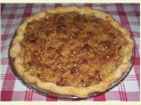

Photo by BelleTerre

* timer
* **Prep Time:** 30 mins
* **Total Time:** 1 hrs 5 mins
* **Serves:** 8, **Yield:** 1 pie

Ingredients

* + 2 1/4 lbs of johnathan apples
  + 3 tablespoons flour
  + 1/3 cup sugar
  + 1 teaspoon cinnamon
  + 1/2 cup flour
  + 1/2 cup brown sugar, firmly packed
  + 1/4 cup pecans
  + 3 tablespoons butter
  + 4 tablespoons caramel topping, your choice
  + 1 (9 inch) pie crusts
  + Usually add cinnamon, and nutmeg to apples for better flavor

Directions

1. Peel, core and slice apples. (You should have about 6 cups.)
2. Mix together the next 3 ingredients and toss in with the apples.
3. Place into prepared pastry.
4. In a separate bowl, mix remaining flour and brown sugar well.
5. Cut in butter until mixture resembles coarse crumbs.
6. Stir in nuts.
7. Sprinkle over apples.
8. Bake at 375°F for 35-45 minutes. Crust will be lightly brown.
9. Remove from oven and place on a wire rack.
10. Drizzle caramel topping over the top and cool completely.
11. Serve with your favorite vanilla ice cream or whip cream. Yum!

### ****Crème Brulee Pie****

Serves:8

1 pint heavy cream

6 egg yolks

½ cup sugar

Pinch of salt

2 tsp vanilla

1 9 inch pie shell

Fine granulated sugar

* Heat heavy cream in a heavy bottomed saucepan over medium heat and bring to a low boil.
* Beat egg yolks with sugar and pinch of salt.
* Mix in the cream, stirring constantly with a wooden spatula or wire whisk until well blended.
* Add vanilla.
* Strain custard into 9 inch pie shell in a pan of warm water and bake in 350 degree oven for 25-30 minutes or until the custard is completely set but not over cooked. Do not let the water in the pan boil.
* Remove from the oven. Cool and then chill in the refrigerator.
* Before serving, sprinkle the top evenly with fine granulated sugar.
* Light handheld torch and caramelize sugar until melted and bubbly, watching carefully to see it does not scorch and burn. You’ll have a hard glazed crust on top of delicious, rich custard.

## ****OTHERS****

### ****Chocolate Mousse Heatter****

**From: Julia Rosenberg**

**½ pound bittersweet chocolate(Tobler Tradition or Lindt Excellence)**

**1 Tbls instant coffee**

**1/3 cup boiling water**

**5 eggs, separated**

**Pinch of salt**

* **Break up the chocolate into a small heavy saucepan.**
* **Dissolve the coffee in boiling water and pour over the chocolate.**
* **Place over low heat and stir occasionally with small wire whisk until mixture is smooth.**
* **Remove from heat and set aside to cool for about 5 minutes**
* **In the small bowl of an electric mixer at high speed, beat the egg yolks for 3 to 4 minutes until a pale lemon color.**
* **Reduce the speed and gradually add the slightly warm chocolate mixture, then fold in a second quarter, and finally fold the chocolate into the remaining whites, folding only until no whites show.**
* **Add salt to the whites and beat until they hold a definite shape but are dry.**
* **Without being too thorough, gently fold about one-quarter of the beaten whites into the chocolate mixture, then fold in a second quarter, and finally fold the chocolate into the remaining whites, folding only until no whites show.**
* **Gently transfer the mousse to a wide pitcher and pour it into six large dessert or wine glasses, each with about a 9-ounce capacity .**
* **Do not fill the glasses too full; leave generous headroom on each. This mousse must be prepared in individual portions. It just will not work if it is all done in one large container.**
* **Top with Mocha Cream(Ctl Clk).**
* **Cover with plastic wrap or aluminum foil and refrigerate 3 to 6 hours.**
* **The mousse may stand longer-12 to 24 hours if you wish. The texture will become spongy and less creamy the longer it sits but is still delicious.**

### ****Mocha Cream****

**From: Julia Rosenberg**

**Yield: 6 portions**

**1 cup heavy cream**

**¼ cup confectioner’s sugar**

**1 Tbls instant coffee(dissolved in a little of the heavy cream and cooled)**

**In a chilled bowl with chilled beaters, beat the heavy cream only until it begins to thicken.**

**Add sugar and coffee, beat until thickened to the consistency of a heavy custard sauce, not stiff.**

**Pour or spoon onto desserts to completely cover the tops.**

**Optional: Top with a light sprinkling of coarsely grated chocolate or place a few large chocolate slabs standing upright in the cream.**

**This recipe may easily be doubled**

# GRANDMOM’S RECIPES

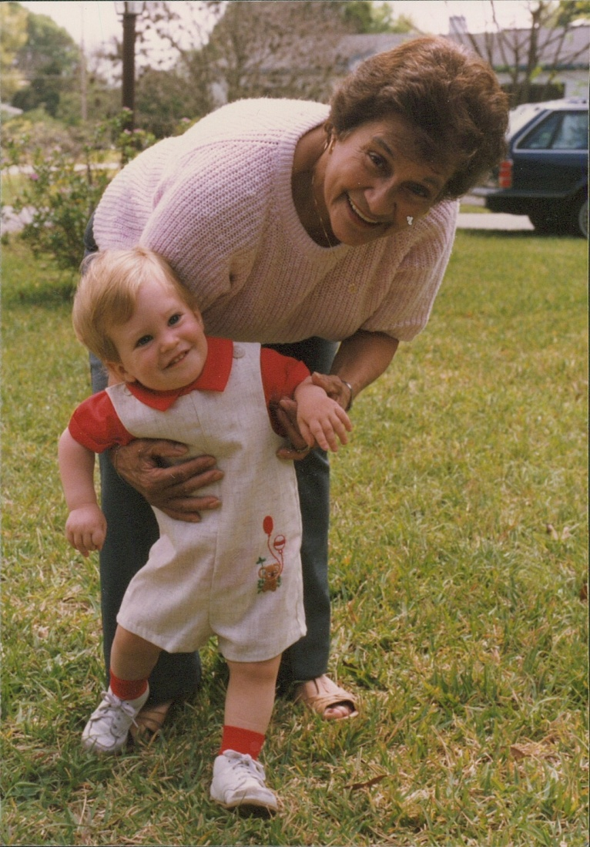

## Italian Sausage Filling

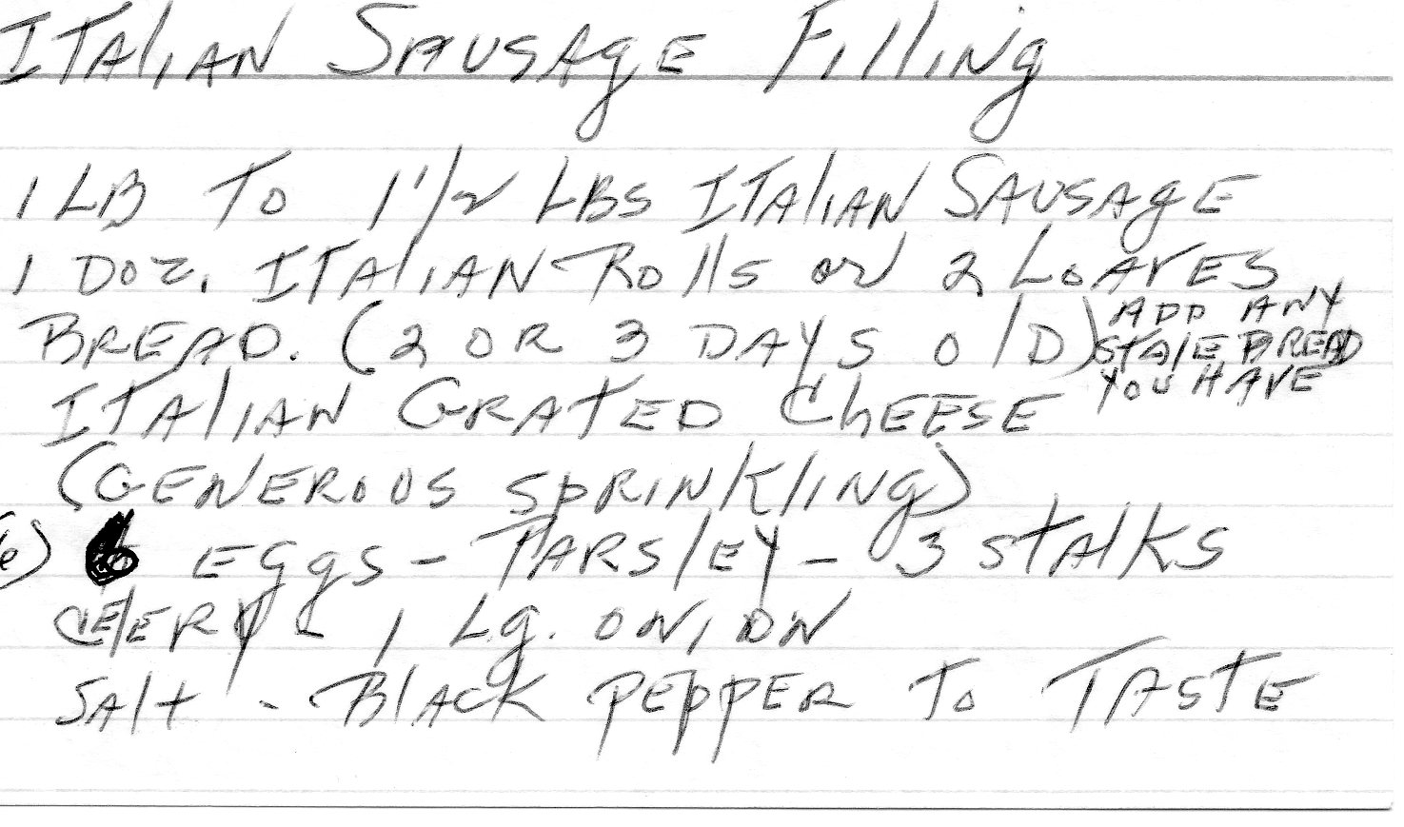

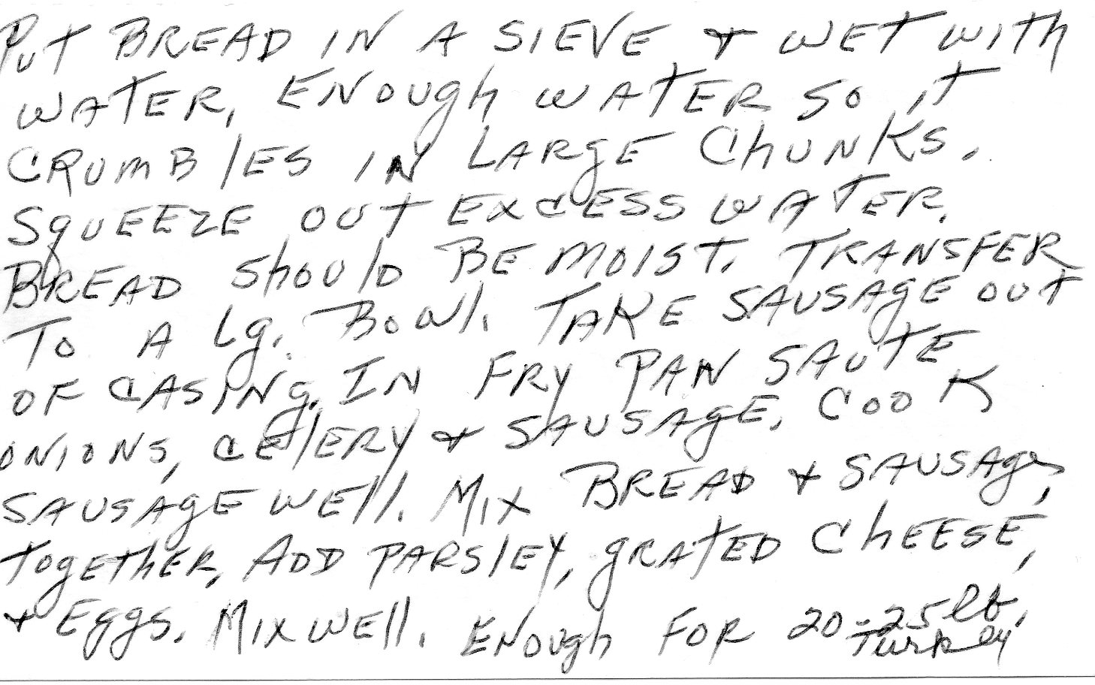

## Escarole Soup(Italian wedding Soup)





## Pastine Soup





## Sausage Egg Quiche





## Zuccini Casserole

1 ½ cup bisquick mix

3-4 zuccini cubed (do not peel)

½ lb mushrooms(optional)

1 tsp basil leaves

½ cup vegetable oil

3 eggs beaten

1 onion

1 tsp oregano

Salt and Pepper to taste

Parmesan cheese, just a sprinkle

Grease 1 ½ quart casserole.

Mix ingredients in casserole.

Bake at 400 for 30-40 minutes

## Waffles

3 eggs separated

1 ½ cup flour

2 tsp baking powder

½ tsp baking soda

1 Tbls sugar

2/3 cup sour cream

¾ cup milk

¼ cup oil

¼ cup melted butter

* Beat egg whites until stiff.
* Combine dry ingredients.
* Beat sour cream, milk, and egg yolks.
* Combine butter, oil, and liquid ingredients alternating with fats and dry ingredients.
* Stir until smooth.
* Fold in egg whites.

## Zucchini Fritters

1 zucchini(large)

1 egg

Bread crumbs

Locatello cheese

Salt and pepper

Onion

Oregano

Basil

* Peel and grate zucchini.
* Combine zucchini, egg, bread crumbs, cheese, salt and pepper, onion, oregano, and basil.
* Drop in spoonfuls in frying pan until brown on both sides.

# Untried But Interesting

## Corn Casserole

Recipe courtesy Paula Deen

Prep Time:

8 min

Inactive Prep Time:

5 min

Cook Time:

55 min

Level:

Easy

Serves:

6 to 8 servings

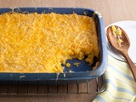

Ingredients

1 (15 1/4-ounce) can whole kernel corn, drained

1 (14 3/4-ounce) can cream-style corn

1 (8-ounce) package corn [muffin](http://www.foodterms.com/encyclopedia/muffin/index.html) mix (recommended: Jiffy)

1 cup [sour cream](http://www.foodterms.com/encyclopedia/sour-cream/index.html)

1/2 cup (1 stick) butter, melted

1 to 1 1/2 cups shredded Cheddar

Directions

Preheat oven to 350 degrees F.

In a large bowl, stir together the 2 cans of corn, corn muffin mix, sour cream, and melted [butter](http://www.foodterms.com/encyclopedia/butter/index.html). Pour into a greased 9 by 13-inch [casserole dish](http://www.foodterms.com/encyclopedia/casserole/index.html). Bake for 45 minutes, or until golden brown. Remove from oven and top with [Cheddar](http://www.foodterms.com/encyclopedia/cheddar/index.html). Return to oven for 5 to 10 minutes, or until [cheese](http://www.foodterms.com/encyclopedia/cheese/index.html) is melted. Let stand for at least 5 minutes and then serve warm.

Grilled Corn with mango-habanero butter

(mango-habanero butter might be good for fish, etc.)

1. 1 mango, peeled and coarsely chopped
2. 1/4 cup mango nectar
3. 1 tablespoon honey
4. 1/2 habanero chile, seeded
5. 1 1/2 sticks unsalted butter, softened
6. 2 tablespoons packed cilantro leaves, chopped
7. 1/2 teaspoon kosher salt
8. 8 ears of corn
9. In a small saucepan, combine the chopped mango with the mango nectar, honey and habanero chile. Bring to a simmer and cook over moderate heat, stirring occasionally, until the mango is very soft, about 10 minutes. Transfer to a food processor and puree until smooth. Strain the mango puree into a small bowl and let cool, about 30 minutes.
10. Wipe out the food processor. Add the cooled mango puree along with the butter, cilantro leaves and salt and puree until smooth. Scrape the mango butter into a small bowl, cover and refrigerate until chilled, about 30 minutes.
11. Light a grill or preheat a grill pan. Pull the corn husks down to the base of the stalks, leaving the husks attached. Discard the corn silk. Using butcher string, tie back the husks. Fill a large bowl with cold, salted water and submerge the corn for 10 minutes.
12. Drain the corn but don't pat dry. Grill the corn over moderate heat, turning occasionally, until tender and browned in spots, about 8 minutes. Transfer the corn to plates, spread with the mango-habanero butter and serve.

Make Ahead The mango-habanero butter can be refrigerated for up to 2 weeks.

## Recipe: Fall Corn Pudding with White Cheddar and Thyme

* Contributed by [Justin Chapple](http://www.foodandwine.com/chefs/justin-chapple) – Food and Wine Magazine
* *ACTIVE:* ***20 MIN***
* *TOTAL TIME:* ***1 HR 15 MIN***
* *SERVINGS:* ***8 to 10***

MAKE-AHEAD

* VEGETARIAN

1. 4 tablespoons unsalted butter, plus more for greasing
2. 1 onion, finely chopped
3. 2 teaspoons minced thyme
4. 4 cups frozen corn kernels (about 20 ounces), thawed
5. 1/2 cup stone-ground cornmeal
6. Kosher salt and freshly ground pepper
7. 5 large eggs
8. 3 cups half-and-half
9. 1 cup shredded sharp white cheddar cheese
10. Preheat the oven to 350°. Butter a 9-by-13-inch shallow ceramic baking dish. In a large skillet, melt the butter. Add the onion and thyme and cook over moderate heat until the onion is softened, about 8 minutes. Remove from the heat. Add the corn and cornmeal and toss to combine. Season with salt and pepper and let cool.
11. In a large bowl, whisk the eggs with the half-and-half. In a blender or food processor, combine 1 cup of the custard with 1 cup of the corn mixture and puree until smooth. Whisk the puree into the custard. Then stir in the corn mixture, cheese, 2 teaspoons of salt and 1/2 teaspoon of pepper until well blended.
12. Spread the mixture in the prepared baking dish and bake for about 40 minutes, until the pudding is slightly puffed and just starting to brown. Let stand for 10 minutes before serving.

Make Ahead The pudding can be prepared through Step 2 and refrigerated overnight. Bring to room temperature before proceeding.

|  |  |
| --- | --- |
| Tilapia Pitas |  |

|  |  |  |  |  |  |
| --- | --- | --- | --- | --- | --- |
| recipe image | |  |  | | --- | --- | | **Rated:** | rating |   **Submitted By:** LAWOODE70  **Photo By:** Raquel   |  |  | | --- | --- | | **Prep Time:** 30 Minutes  **Cook Time:** 7 Minutes | **Ready In:** 37 Minutes  **Servings:** 12 | |

"Tilapia Pita - say it ten times real fast. A delightful light meal. Excellent for weekend afternoon gatherings, and aesthetically pleasing, too! Feel free to experiment with the seasonings and sauce ingredients to match your personal tastes."

**Ingredients:**

|  |  |
| --- | --- |
| 1/2 cup mayonnaise  1/4 cup Italian salad dressing  1/2 cup crumbled feta cheese  2 anchovy fillets, drained  1 pinch cayenne pepper, or to taste  1/8 teaspoon ground black pepper, or to  taste  1 pinch salt | 3 tablespoons olive oil  1 pound tilapia fillets  1/4 teaspoon lemon pepper  salt and cayenne pepper to taste  4 cups iceberg lettuce, torn into bite  -sized pieces  1 small red onion, chopped  6 pita breads, cut in half |

**Directions:**

|  |  |
| --- | --- |
| **1.** | In a small bowl, stir together the mayonnaise, Italian dressing, feta cheese and anchovies. Season with cayenne pepper, black pepper and salt. Mix until well blended, then set aside. |
| **2.** | Heat oil in a large skillet over medium-high heat. Place the tilapia fillets in the skillet, and season with lemon pepper, salt and cayenne. Fry until browned on each side, and fish flakes easily with a fork, 5 to 7 minutes. |
| **3.** | Warm pita breads in the toaster or in the microwave to soften. Open from the cut side to make pockets. Fill pita bread halves with lettuce, onion, and tilapia fillets, then spoon in some of the feta cheese sauce. Serve and enjoy! |

|  |  |
| --- | --- |
| ALL RIGHTS RESERVED © 2012 Allrecipes.com | Printed from Allrecipes.com 2/12/2012 |

|  |  |  |  |  |  |  |  |  |  |  |  |  |  |  |
| --- | --- | --- | --- | --- | --- | --- | --- | --- | --- | --- | --- | --- | --- | --- |
| |  |  |  |  |  |  | | --- | --- | --- | --- | --- | --- | | recipe image | |  |  | | --- | --- | | Rated: | rating |   Submitted By: MARBALET  Photo By: fluteplayer35   |  |  | | --- | --- | | Prep Time: 5 Minutes  Cook Time: 10 Minutes | Ready In: 15 Minutes  Servings: 4 | |   "Stir-fried beef with snow peas in a light gingery sauce."  Ingredients:   |  |  | | --- | --- | | 3 tablespoons soy sauce  2 tablespoons rice wine  1 tablespoon brown sugar  1/2 teaspoon cornstarch  1 tablespoon vegetable oil | 1 tablespoon minced fresh ginger root  1 tablespoon minced garlic  1 pound beef round steak, cut into thin  strips  8 ounces snow peas |   Directions:   |  |  | | --- | --- | | 1. | In a small bowl, combine the soy sauce, rice wine, brown sugar and cornstarch. Set aside. | | 2. | Heat oil in a wok or skillet over medium high heat. Stir-fry ginger and garlic for 30 seconds. Add the steak and stir-fry for 2 minutes or until evenly browned. Add the snow peas and stir-fry for an additional 3 minutes. Add the soy sauce mixture, bring to a boil, stirring constantly. Lower heat and simmer until the sauce is thick and smooth. Serve immediately. |  |  |  | | --- | --- | | ALL RIGHTS RESERVED © 2012 Allrecipes.com | Printed from Allrecipes.com 2/12/2012 | |

[Click here to find out more!](http://ad.doubleclick.net/click;h=v8/3c19/0/0/*/g;44306;0-0;0;12085196;2321-160/600;0/0/0;u=%5bCS%5dv1|279BE2F1851D29E2-400001080001815D%5bCE%5d;~okv=;rsi=D11170_10012;rsi=D11170_10072;dcopt=ist;status=unrecognized;u=%5bCS%5dv1|279BE2F1851D29E2-400001080001815D%5bCE%5d;r=15679;u=dSQRM|279BE2F1851D29E2-400001080001815D|R15679|||||u|;tile=2;sz=160x600;~aopt=2/1/d5/1;~sscs=?)

[Click here to find out more!](http://ad.doubleclick.net/click;h=v8/3bfd/0/0/*/g;44306;0-0;0;12085196;2321-160/600;0/0/0;u=%5bCS%5dv1|2789728A851D2559-6000012E6028EB92%5bCE%5d;~okv=;rsi=D11170_10012;dcopt=ist;status=unrecognized;u=%5bCS%5dv1|2789728A851D2559-6000012E6028EB92%5bCE%5d;r=12942;u=1,1|2789728A851D2559-6000012E6028EB92|R12942|||||u|;tile=2;sz=160x600;bsg=106144;bsg=109729;;~aopt=2/1/d5/1;~sscs=?)